A
Real-Time Research Project On
Detecting and Mitigating Botnet Attacks in Software-Defined Networks Using Deep Learning Techniques
(Submitted in partial fulfillment of the requirements for the award of Degree)

BACHELOR OF TECHNOLOGY
In

COMPUTER SCIENCE AND ENGINEERING
By
Under the Guidance of

A.Divya Bharati
(Assistant Professor)


DEPARTMENT OF COMPUTER SCIENCE AND ENGINEERING
CMR TECHNICAL CAMPUS
UGC AUTONOMOUS
(Accredited by NAAC, NBA, Permanently Affiliated to JNTUH, Approved by AICTE, New Delhi)
Recognized Under Section 2(f) & 12(B) of the UGCAct.1956, Kandlakoya (V), Medchal Road, Hyderabad-501401.
April, 2026.

DEPARTMENT OF COMPUTER SCIENCE AND ENGINEERING


CERTIFICATE

This is to certify that the project entitled “Detecting and Mitigating Botnet Attacks in Software-Defined Networks Using Deep Learning Techniques” being submitted by U.VARSHITHA (247R1A05CG), T.SAI LALITH CHANDRA (247R1A05CF) & D.SHASHI KUMAR (247R1A05AD) in partial fulfillment of the requirements for the award of the degree of B.Tech in Computer Science and Engineering to the Jawaharlal Nehru Technological University Hyderabad, during the year 2025-26.

The results embodied in this thesis have not been submitted to any other University or Institute for the award of any degree or diploma.

A.Divya Bharati Dr. Nuthanakanti Bhaskar Assistant Professor HoD
INTERNAL GUIDE

ACKNOWLEDGEMENT

We take this opportunity to express our gratitude to the people who have been instrumental in the successful completion of this project. We take this opportunity to express our profound gratitude and deep regard to our guide A. Divya Bharati, Assistant Professor, for her exemplary guidance, monitoring, and constant encouragement throughout the project work. The blessing, help, and guidance given by her shall carry us a long way in the journey of life on which we are about to embark.

We take this opportunity to extend our heartfelt appreciation to the Project Review Committee (PRC) Coordinators—Dr. J. Narasimharao, Mrs. M. Srilekha, Dr. G. Venkateshwarlu Nayak, and Mrs. A. Divya Bharati—for their unwavering support, insightful guidance, and valuable inputs, which played a crucial role in steering this project through its various stages.

Our sincere appreciation also goes to Dr. Nuthanakanti Bhaskar, Head, for his encouragement and continuous support in ensuring the successful completion of our project.

We are deeply grateful to Dr. A. Raji Reddy, Director, for his cooperation throughout the course of this project. Additionally, we extend our profound gratitude to Sri. Ch. Gopal Reddy (Chairman), Smt. C. Vasantha Latha (Secretary), and Sri. C. Abhinav Reddy (Vice-Chairman) for fostering an excellent infrastructure and a conducive learning environment that greatly contributed to our progress.

We also acknowledge and appreciate the guidance and assistance provided by the faculty and staff of CMR Technical Campus, whose contributions have been invaluable in bringing this project to fruition.

Lastly, we sincerely thank our families for their unwavering support and encouragement. We also extend our gratitude to the teaching and non-teaching staff of CMR Technical Campus for their guidance and assistance. Their contributions, along with the support of everyone who helped directly or indirectly, have been invaluable in the successful completion of this project.

U.VARSHITHA 2 47R1A05CG
T.SAI LALITH CHANDRA 247R1A05CF
D.SASHI KUMAR 247R1A05AD

VISION AND MISSION

INSTITUTE VISION:
To Impart quality education in serene atmosphere thus strive for excellence in Technology and Research.

INSTITUTE MISSION:
- To create state of art facilities for effective Teaching- Learning Process.

- Pursue and Disseminate Knowledge based research to meet the needs of Industry & Society.

- Infuse Professional, Ethical and Societal values among Learning Community.

DEPARTMENT VISION:
To provide quality education and a conducive learning environment in computer engineering that foster critical thinking, creativity, and pracical problem-solving skills.

DEPARTMENT MISSION:
- To educate the students in fundamental principles of computing and induce the skills needed to solve practical problems.

- To provide State-of-the-art computing laboratory facilities to promote industry institute interaction to enhance student’s practical knowledge.

- To inculcate self-learning abilities, team spirit, and professional ethics among the students to serve society.

ABSTRACT

Software-Defined Networking (SDN) is an emerging architecture that enables flexible and easy management and communication of large-scale networks. It offers programmable and centralized interfaces for making complex network decisions dynamically and seamlessly. However, SDN provides opportunities for businesses and individuals to build network applications based on their demands and improve their services. In contrast, it started to face a new array of security and privacy challenges and simultaneously introduced the threats of a single point of failure. Usually, attackers launch malicious attacks such as botnets and Distributed Denial of Service (DDoS) to the controller through Open Flow switches. Deep learning (DL)-based security applications are trending, effectively detecting and mitigating potential threats with fast response. In this article, we analyze and show the performance of the DL methods to detect botnet-based DDoS attacks in an SDN-supported environment. A newly self-generated dataset is used for the evaluation.
We also used feature weighting and tuning methods to select the best subset of features. We verify the measurements and simulation outcomes over a self-generated dataset and real testbed settings. The main aim of this study is to find a lightweight DL method with baseline hyper-parameters to detect botnet-based DDoS attacks with features and data that can be easily acquired. We observed that the best subset of features influences the performance of the DL method, and the prediction accuracy of the same method could be variated with a different set of features. Finally, based on empirical results, we found that the CNN method outperforms the dataset and real testbed settings. The detection rate of CNN reaches 99% for normal flows and 97% for attack flows

EXISTING SYSTEM

Researchers have recently proposed various ML and DL-based methods for detecting botnet attacks. Some appropriate research works have been done in DDoS and botnet attack detection. [15] proposed ‘‘high-level PSI-rooted sub graph-based features’’ to detect the botnets in IoT, and they also used a hybrid combination of machine learning and deep learning methods. Their main aim was to detect the attack with a minimum number of features that can help to reduce the space and faster the detection speed. Reference [16] developed an IoT botnet sensor system based on unsupervised learning. They do the hyper parameterization of SVM using the ‘‘Grey Wolf Optimization (GWO) algorithm’’ to determine the critical features for a botnet attack.

The suggested technique helps to detect IoT botnet attacks launched from intelligent, vulnerable nodes. We observed another network-based anomaly detection approach called N-BaIoT in [17], which takes snapshots of the network behavior and employs deep auto encoders to detect the attack traffic. Reference [18] proposed a hybrid method of PSO algorithms with a voting mechanism to detect botnet attacks in IoT. In this method, the PSO is used to pick the critical and remarkable features, and the election process is performed using DNN, Decision Tree (DT) C4.5, and SVM to detect the botnet attacks. In another research [19], the authors proposed a CNN-based method named BoTIDS. They observed that this method produced good results on a complete dataset and a predefined subset of 10 features compared to LSTM and RNN. However, the evaluation results on a subset are comparatively better than the full dataset. We observed another CNN-based Anomaly Intrusion Detection System (AIDS) [20]. This system is tested on BoT-IoT and Network Intrusion Detection (NID) datasets. The proposed system produced effective results on the NID dataset compared to BoT-IoT. In [8], we observed a two-level DDoS attack detection method based on DL and Information Entropy (IE). First, they used information entropy to detect the suspicious port and components in coarse granularity. Then, they executed a CNN-based fine-grained detection mechanism to classify the attack and normal traffic. Reference [21] developed a DNN-based network intrusion detection system to show the potential of DL methods for malicious traffic detection. A combined method of Autoencoder and RNN named DDoSNet has been proposed by [22] to detect DDoS attacks in SDN environments. Reference [23] proposed an LSTM-based DDoS detection method and compared the performance of this method with Random-Forest (RF) based approach, and it reduced the error rate from 7.517% to 2.103%. Reference [24] present a deep learning-based lightweight and practical DDoS detection system called LUCID, which shows the capabilities of CNN to classify traffic flows as normal or malicious. Reference [25] proposed a method based on SVM, assisted by Genetic Algorithm (GA) and Kernel Principle Component Analysis (KPCA).
Reference [27] improved the DDoS attack detection performance using a trigger mechanism for the first time. This method helps reduce the overhead of the switches and controller. Another hybrid method based on Artificial Neural Networks (ANNs) andDNNwas proposed in [28]. To classify the major bot attacks as Emotet, Zbot, Dridex, and Sality, the authors used a combined method of RNN and LSTM [29].

Another hybrid method based on LSTM and CNN was proposed in [30]. They deployed this method in a real testbed which used data gathered from nine commercial IoT devices to detect the attack. In [31], the authors proposed a distributed method based on CNN and LSTM with an additional cloud-based component for detecting DDoS and phishing attacks. Reference [32] introduced a method combining Fuzzy and Taylor-Elephant Herd Optimization (F-TEHO) inspired by Deep Belief Network (DBN) to detect DDoS attacks. This method compromises three modules: feature extraction, selection, and classification.

The feature extraction module extracts feature from raw packet data, and then the Holo-entropy method is used to select essential features. Finally, the classification process is performed using the FTEHO method. Another method based on cognitive-inspired computing with dual address entropy is proposed in [33]. In this method, the dual address entropy is first used to extract the features from the flow table, and then SVM classifies the traffic as normal or attack. This method helps to detect the attack at the preliminary stage and restore the usual communication in time

Disadvantages
• The complexity of data: Most of the existing machine learning models must be able to accurately interpret large and complex datasets to detect Botnet Attacks.
• Data availability: Most machine learning models require large amounts of data to create accurate predictions. If data is unavailable in sufficient quantities, then model accuracy may suffer.
• Incorrect labeling: The existing machine learning models are only as accurate as the data trained using the input dataset. If the data has been incorrectly labeled, the model cannot make accurate predictions.
Proposed System

The proposed work aims to conduct a comparative study on deep learning methods with optimized feature selection from network traffic flow to detect the botnet-based DDoS attack in an SDN environment. The selection of optimal features can improve DL methods’ detection performance and accuracy and can help to reduce the SDN controller’s overhead.

As we know, botnet attacks can hijack the controller and launch malicious activities. So, DL-based techniques and dedicated bot management are optimal solutions for SDN to deal with botnet traffic. The progressive development in security measures of SDN has motivated us to develop a DL method named ‘‘DepBot’’ to detect and mitigate botnet-based DDoS.

Advantages

• Optimal Features: Compressing multiple features and identifying the most optimal features is our one contribution. In this, a comparison of DL methods is performed to detect the botnet-based DDoS. The methods have experimented on a custom-developed dataset.
• Factor Analysis: We select and retrieve the optimal features into different subsets. We use feature weighting and threshold tuning-based evaluation techniques to choose the best feature subset. Based on this, we have identified optimal features and converted them into five subsets.
• DL Analysis: We select and use the five DL methods, such as Recurrent Neural Network (RNN), Convolutional Neural Network (CNN), Multilayer Perception (MLP), Long Short Term Memory (LSTM), and Deep Neural Network (DNN), that mostly appears in network intrusion detection-based applications. We use time-series-based techniques in RNN and LSTM to develop the detection methods.

• Performance: The performance of the DL methods is evaluated using accuracy, precision, detection rate, and F1-score metrics. These methods build a relationship with raw data through multiple levels of abstraction. We observed that the DL methods produce good results on subset 3. This study would help to select the optimal features and best DL method for botnet-based DDoS attack detection in SDN.
• Mitigation: We used graph theory and dynamic flow deletion concepts to adopt a more targeted flow dropping strategy.

SYSTEM REQUIREMENTS

➢ H/W System Configuration:-

➢ Processor - Pentium –IV

➢ RAM - 4 GB (min)
➢ Hard Disk - 20 GB
➢ Key Board - Standard Windows Keyboard
➢ Mouse - Two or Three Button Mouse
➢ Monitor - SVGA

SOFTWARE REQUIREMENTS:
- Operating system : Windows 7 Ultimate.
- Coding Language : Python.
- Back-End : Django-ORM
- Designing : Html, css, javascript.
- Data Base : MySQL.

TABLE OF CONTENTS

ABSTRACT 3
SYSTEM REQUIREMENTS
- INTRODUCTION 11
  - PROJECT PURPOSE 12
  - PROJECT OBJECTIVE 13
- LITERATURE SURVEY
  - DEFINITION OF PROBLEM STATEMENT 15
  - EXISTING SYSTEM 19
  - PROPOSED SYSTEM 19
  - REQUIREMENTS 20
    - SOFTWARE REQUIREMENTS 20
- SYSTEM ARCHITECTURE & DESIGN 14
  - PROJECT ARCHITECTURE 24
  - DESCRIPTION 27
  - DATA FLOW DIAGRAM 36
- IMPLEMENTATION 38
  - SAMPLE CODE 41
- RESULTS & DISCUSSION 49
- VALIDATION
  - TESTING 61
  - TEST CASES 64
- CONCLUSION
  - PROJECT CONCLUSION 66
- BIBLIOGRAPHY
  - REFERENCES 55

1.INTRODUCTION

The development of the internet is rapidly growing; the limitations of traditional networks have been explored. The emerging issues of the conventional networks can be solved by patching the network, which makes the network more bloated and the control ability of the network becomes weaker. The invention of Software-Defined Networking (SDN) has resolved these problems by decoupling the data and control planes. SDN became famous among the associate editor coordinating the review of this manuscript and approving it for publication was Cheng Chin . network community due to its novel architecture and can fulfill the demands of fast-growing networks. SDN has a centralized control architecture, so the SDN controllers can access all the OpenFlow switches in their range and control the entire network through the open south API interfaces. It is also known as the three-layer network architecture, application, control, and data layers. The application layer runs all the policies and rules the network administrator defines, and the SDN controller can adopt these rules dynamically. Any modification in the application layer may change the behaviour of the whole network. The application layer is an excellent development by the open-source platform, VOLUME 11, 2023 49153 IEEE Transaction on Machine Learning, Volume:11, Issue Date:17. May.2023 which does not force the administrator to entirely relies on vendors. Positively, the SDN allows administrators to eliminate license constraints and cloud-develop customized network applications over general-purpose hardware. The control layer is known as the brain of the architecture, and SDN controllers run in this layer. The controllers receive the rules from the application layer, decode them into readable messages, and forward them to the underlying data layer; after that, they collect the feedback from the data layer and pass it back to the application layer. Moreover, a decision is made on the control layer, and the rules are implemented in the data layer. The data layer is non-intelligent, and different hardware devices, such as routers, OpenFlow switches, etc., exist in this layer, and instructions are passed by the control layer. Furthermore, it simplifies and eases the network’s development, deployment, and maintenance. The network functions and features can be easily enhanced by updating and introducing new applications. Besides being cost-effective, SDN based networks require simple hardware devices and have almost no compatibility issues. Network access is allowed without revealing the details of the different underlying layers. Although SDN is an inordinate invention that can improve the network’s flexibility and controllability and is considered a double-edged sword due to central control, a single controller can easily manage the network. SDN also helps to improve traditional networks’ security measures, but SDN has yet to be extensively trustworthy security measures to support the vision of next-generation networking. Due to its centralized control nature and innovative architecture, it may introduce new security threats and can lead toward a single point of failure. Furthermore, the centralized nature of SDN architecture unlocks the way for attackers to launch different attacks such as botnets, DDoS, saturation, and other types. Botnet attacks are considered malicious attacks that become a critical threat in the next generation of networking. The botnet is a network-based attack that breaches multiple computers into ‘‘bots’’ to launch malicious activities such as DDoS, identifying theft, domain name system spoofing, spamming, phishing, etc. In a botnet attack, a malicious actor, ‘‘Bot master,’’ tries to get unauthorized access to a single device and then implements botnet malware to take control of the device without alienating its legitimate users. After that, establish a connection of bots with a Command and Control (C&C) centre owned by the attacker, and the bots remain ready to launch malicious activities under the instructions of C&C. Currently, botnet technology is typically used to launch the most sophisticated DDoS attacks in SDN and Internet of Things (IoT) based networks. The power and flexibility of the technology enable the botnet technology to generate several types of DDoS attacks
Objective of the project:
Software-Defined Networking (SDN) is an emerging architecture that enables flexible and easy management and communication of large-scale networks. It offers programmable and centralized interfaces for making complex network decisions dynamically and seamlessly. However, SDN provides opportunities for businesses and individuals to build network applications based on their demands and improve their services. In contrast, it started to face a new array of security and privacy challenges and simultaneously introduced the threats of a single point of failure. Usually, attackers launch malicious attacks such as botnets and Distributed Denial of Service (DDoS) to the controller through OpenFlow switches. Deep learning (DL)-based security applications are trending, effectively detecting and mitigating potential threats with fast response. In this article, we analyse and show the performance of the DL methods to detect botnet-based DDoS attacks in an SDN-supported environment. A newly self-generated dataset is used for the evaluation. We also used feature weighting and tuning methods to select the best subset of features. We verify the measurements and simulation outcomes over a self-generated dataset and real testbed settings. The main aim of this study is to find a lightweight DL method with baseline hyper-parameters to detect botnet-based DDoS attacks with features and data that can be easily acquired. We observed that the best subset of features influences the performance of the DL method, and the prediction accuracy of the same method could be variated with a different set of features. Finally, based on empirical results, we found that the CNN method outperforms the dataset and real testbed settings. The detection rate of CNN reaches 99% for normal flows and 97% for attack flows

2.LITERATURE SURVEY

- A taxonomy of network threats and the effect of current datasets on intrusion detection systems
- As the world moves towards being increasingly dependent on computers and automation, building secure applications, systems and networks are some of the main challenges faced in the current decade. The number of threats that individuals and businesses face is rising exponentially due to the increasing complexity of networks and services of modern networks. To alleviate the impact of these threats, researchers have proposed numerous solutions for anomaly detection; however, current tools often fail to adapt to ever-changing architectures, associated threats and zero-day attacks. This manuscript aims to pinpoint research gaps and shortcomings of current datasets, their impact on building Network Intrusion Detection Systems (NIDS) and the growing number of sophisticated threats. To this end, this manuscript provides researchers with two key pieces of information; a survey of prominent datasets, analysing their use and impact on the development of the past decade's Intrusion Detection Systems (IDS) and a taxonomy of network threats and associated tools to carry out these attacks. The manuscript highlights that current IDS research covers only 33.3% of our threat taxonomy. Current datasets demonstrate a clear lack of real-network threats, attack representation and include a large number of deprecated threats, which together limit the detection accuracy of current machine learning IDS approaches. The unique combination of the taxonomy and the analysis of the datasets provided in this manuscript aims to improve the creation of datasets and the collection of real-world data. As a result, this will improve the efficiency of the next generation IDS and reflect network threats more accurately within new datasets.
- Elearning: Challenges and research opportunities using machine learning data analytics
- With the proliferation of technology, the field of e-learning has garnered significant attention in recent times. This is because it has allowed users from around the world to learn and access new information. This has added to the growing amount of collected data that is already being generated through different devices and sensors employed around the world. This has led to the need to analyze collected data and extract useful information from it. Machine learning (ML) and data analytics (DA) are proposed techniques that can help extract information and find valuable patterns within the collected data. In this paper, the field of e-learning is investigated in terms of definitions and characteristics. Moreover, the various challenges facing the different participants within this process are discussed. In addition, some of the works proposed in the literature to tackle these challenges are presented. Then, a brief survey about some of the most popular ML and DA techniques is given. Finally, some of the research opportunities available that employ such techniques are proposed to give insights into the areas that merit further exploration and investigation.
- Cisco Predicts More IP Traffic in the Next Five Years Than in the History of the Internet
- Yet the new Visual Networking Index (VNI) by Cisco predicts that is just the beginning. By 2022, more IP traffic will cross global networks than in all prior ‘internet years’ combined up to the end of 2016. In other words, more traffic will be created in 2022 than in the 32 years since the internet started. Where will that traffic come from? All of us, our machines and the way we use the internet. By 2022, 60 percent of the global population will be internet users. More than 28 billion devices and connections will be online. And video will make up 82 percent of all IP traffic. The size and complexity of the internet continues to grow in ways that many could not have imagined. Since we first started the VNI Forecast in 2005, traffic has increased 56-fold, amassing a 36 percent CAGR with more people, devices and applications accessing IP networks,” said Jonathan Davidson, senior vice president and general manager, Service Provider Business, Cisco. “Global service providers are focused on transforming their networks to better manage and route traffic, while delivering premium experiences. Our ongoing research helps us gain and share valuable insights into technology and architectural transitions our customers must make to succeed.
- The rise of internet of things (iot) in big healthcare data: review and open research issues
- Health is one of the sustainable development areas in all of the countries. Internet of Things has a variety of use in this sector which was not studied yet. The aim of this research is to prioritize IoT usage in the healthcare sector to achieve sustainable development. The study is an applied descriptive research according to data collection. As per the research methodology which is FAHP, it is a single cross-sectional survey research. After data collection, the agreed paired comparison matrices, allocated to weighted criteria and the priority of IoT usage were determined. Based on the research findings, the two criteria of “Economic Prosperity” and “Quality of Life” achieved the highest priority for IoT sustainable development in the healthcare sector. Moreover, the top priorities for IoT in the area of health, according to the usage, were identified as “Ultraviolet Radiation”, “Dental Health” and “Fall Detection”.
- Iot-based smart cities: A survey
- Due to the growing developments in advanced metering and digital technologies, smart cities have been equipped with different electronic devices on the basis of Internet of Things (IoT), therefore becoming smarter than before. The aim of this article is that of providing a comprehensive review on the concepts of smart cities and on their motivations and applications. Moreover, this survey describes the IoT technologies for smart cities and the main components and features of a smart city. Furthermore, practical experiences over the world and the main challenges are explained.
- A continuous diversified vehicular cloud service availability framework for smart cities
- The intelligent and connected transportation system (ICTS) is a significant and mandatory component of the smart city architecture. Multimedia content sharing, vehicle power management, and road navigation are all examples of ICTS services. As smart cities continue to deploy different technologies to improve the performance and diversity of vehicular cloud services, one of the main issues that prevails is efficient and reliable service discovery and selection for smart vehicles. Furthermore, cloud service providers (SPs) are limited to the availability, variety and quality of services made available to vehicular cloud subscribers. Smart vehicles rely on a number of SPs to acquire the required services while moving. It therefore becomes challenging for vehicular cloud subscribers to acquire services that meet their quality of experience (QoE) preferences. This paper introduces a new service provision scheme to provide continuous availability of diversified cloud services targeting vehicular cloud users through a cluster-based trusted third party (TTP) framework. TTPs act as cloud service mediators between cloud service subscribers and providers. Vehicles that are considered to have similar patterns of movement and service acquisition characteristics are grouped into service-specific clusters. TTPs communicate with service providers and cluster heads to negotiate for services with high QoE characteristics. A location prediction method is adopted to determine a vehicle's future location and allow services to be negotiated for before the vehicle's arrival. We provide simulation results to show that our approach can adequately discover and deliver cloud services with increased QoE results, minimal overhead burden and reduced end-to-end latency.

3.SYSTEM ARCHITECTURE & DESIGN

3.1 Existing System
In Existing system, using Default Decision Tree and SVM algorithms for Detecting Botnet Attacks in IoT Environments.
Disadvantages:
- Less Accuracy
- More time taking process

3.2 PROPOSED SYSTEM
In proposed system, using BOGP Optimized Decision tree algorithm. And also using deep learning algorithm CNN (Convolution Neural Networks) which will optimized dataset features using multiple layers and neurons and can able to select more optimized features which can help in better prediction accuracy compares to other algorithms.

Advantages:
- High Accuracy
- Takes less time
Modules Information:
To implement this project we have used same dataset given in your requirement file and to implement this project we have designed following modules
- Upload dataset: using this module, we will upload datasets
- Dataset preprocessing: using this module, we will split and clean the data
- Run Default Decision Tree Algorithm: using this module, training Default Decision Tree algorithm and gets 99.23% as the accuracy
- Run BOGP Optimized Decision Tree Algorithm: using this module, training decision tree with best selected BOGP parameters and after training optimized decision tree got 99.30% accuracy which is higher than default decision tree
- Run SVM Algorithm: using this module, training existing SVM algorithm and it got 96% accuracy
- Run CNN Algorithm: using this module, training extension CNN and got 99.996% accuracy
- Comparison Graph: using this module, displaying comparison between all algorithms where x-axis represents algorithm names and y-axis represents accuracy and other metrics in different colour bars and in all algorithms extension CNN got high performance
FUNCTIONAL REQUIREMENTS:
SOFTWARE REQIREMENTS:
System Atributes:
- Filename
- dataset
- X, Y, mse, X_train, X_test, y_train, y_test
Prototype:
python 3.7.0 or 3.7.4
opencv-python==4.5.1.48
keras==2.3.1
tensorflow==1.14.0
protobuf==3.16.0
h5py==2.10.0
sklearn-extensions==0.0.2
scikit-learn==0.22.2.post1
Numpy
Pandas
NON-FUNCTIONAL REQUIREMENT:
Usability: Usability is a quality attribute that assesses how easy user interfaces are to use. The word "usability" also refers to methods for improving ease-of-use during the design process.(how it was handle entire project easy)
Security: the quality or state of being secure: such as. a : freedom from danger : safety. b : freedom from fear or anxiety. c : freedom from the prospect of being laid off job security.
Readability: Readability is the ease with which a reader can understand a written text.
Performance: the execution of an action. : something accomplished : deed, feat. : the fulfillment of a claim, promise, or request : implementation. 3. : the action of representing a character in a play.
Availability: the quality or state of being available trying to improve the availability of affordable housing. 2 : an available person or thing.
Scalability: Scalability is the measure of a system's ability to increase or decrease in performance and cost in response to changes in application and system processing demands.
3.3. PROCESS MODEL USED WITH JUSTIFICATION
SDLC (Umbrella Model):

Umbrella Activity
Umbrella Activity
Umbrella Activity
- Feasibility Study
- TEAM FORMATION
- Project Specification PREPARATION

Business Requirement Documentation
ANALYSIS & DESIGN
CODE
UNIT TEST
DOCUMENT CONTROL

ASSESSMENT

TRAINING
INTEGRATION & SYSTEM TESTING

DELIVERY/INSTALLATION
ACCEPTANCE TEST
Requirements Gathering

SDLC is nothing but Software Development Life Cycle. It is a standard which is used by software industry to develop good software.
Stages in SDLC:
- Requirement Gathering
- Analysis
- Designing
- Coding
- Testing
- Maintenance

Requirements Gathering stage:
The requirements gathering process takes as its input the goals identified in the high-level requirements section of the project plan. Each goal will be refined into a set of one or more requirements. These requirements define the major functions of the intended application, define operational data areas and reference data areas, and define the initial data entities. Major functions include critical processes to be managed, as well as mission critical inputs, outputs and reports. A user class hierarchy is developed and associated with these major functions, data areas, and data entities. Each of these definitions is termed a Requirement. Requirements are identified by unique requirement identifiers and, at minimum, contain a requirement title and textual description.

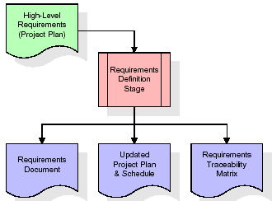
These requirements are fully described in the primary deliverables for this stage: the Requirements Document and the Requirements Traceability Matrix (RTM). The requirements document contains complete descriptions of each requirement, including diagrams and references to external documents as necessary. Note that detailed listings of database tables and fields are not included in the requirements document.
The title of each requirement is also placed into the first version of the RTM, along with the title of each goal from the project plan. The purpose of the RTM is to show that the product components developed during each stage of the software development lifecycle are formally connected to the components developed in prior stages.
In the requirements stage, the RTM consists of a list of high-level requirements, or goals, by title, with a listing of associated requirements for each goal, listed by requirement title. In this hierarchical listing, the RTM shows that each requirement developed during this stage is formally linked to a specific product goal. In this format, each requirement can be traced to a specific product goal, hence the term requirements traceability.
The outputs of the requirements definition stage include the requirements document, the RTM, and an updated project plan.
- Feasibility study is all about identification of problems in a project.
- No. of staff required to handle a project is represented as Team Formation, in this case only modules are individual tasks will be assigned to employees who are working for that project.
- Project Specifications are all about representing of various possible inputs submitting to the server and corresponding outputs along with reports maintained by administrator.
Analysis Stage:
The planning stage establishes a bird's eye view of the intended software product, and uses this to establish the basic project structure, evaluate feasibility and risks associated with the project, and describe appropriate management and technical approaches.
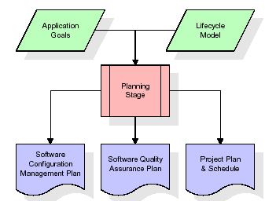

The most critical section of the project plan is a listing of high-level product requirements, also referred to as goals. All of the software product requirements to be developed during the requirements definition stage flow from one or more of these goals. The minimum information for each goal consists of a title and textual description, although additional information and references to external documents may be included. The outputs of the project planning stage are the configuration management plan, the quality assurance plan, and the project plan and schedule, with a detailed listing of scheduled activities for the upcoming Requirements stage, and high level estimates of effort for the out stages.
Designing Stage:
The design stage takes as its initial input the requirements identified in the approved requirements document. For each requirement, a set of one or more design elements will be produced as a result of interviews, workshops, and/or prototype efforts. Design elements describe the desired software features in detail, and generally include functional hierarchy diagrams, screen layout diagrams, tables of business rules, business process diagrams, pseudo code, and a complete entity-relationship diagram with a full data dictionary. These design elements are intended to describe the software in sufficient detail that skilled programmers may develop the software with minimal additional input.
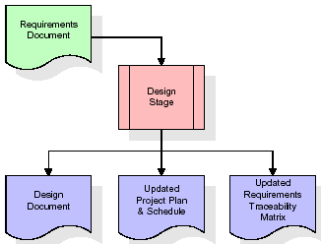

When the design document is finalized and accepted, the RTM is updated to show that each design element is formally associated with a specific requirement. The outputs of the design stage are the design document, an updated RTM, and an updated project plan.
Development (Coding) Stage:
The development stage takes as its primary input the design elements described in the approved design document. For each design element, a set of one or more software artifacts will be produced. Software artifacts include but are not limited to menus, dialogs, and data management forms, data reporting formats, and specialized procedures and functions. Appropriate test cases will be developed for each set of functionally related software artifacts, and an online help system will be developed to guide users in their interactions with the software.
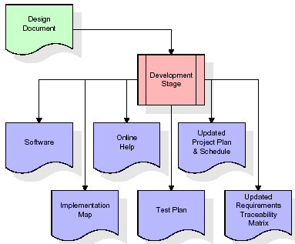

The RTM will be updated to show that each developed artifact is linked to a specific design element, and that each developed artifact has one or more corresponding test case items. At this point, the RTM is in its final configuration. The outputs of the development stage include a fully functional set of software that satisfies the requirements and design elements previously documented, an online help system that describes the operation of the software, an implementation map that identifies the primary code entry points for all major system functions, a test plan that describes the test cases to be used to validate the correctness and completeness of the software, an updated RTM, and an updated project plan.
Integration & Test Stage:
During the integration and test stage, the software artifacts, online help, and test data are migrated from the development environment to a separate test environment. At this point, all test cases are run to verify the correctness and completeness of the software. Successful execution of the test suite confirms a robust and complete migration capability. During this stage, reference data is finalized for production use and production users are identified and linked to their appropriate roles. The final reference data (or links to reference data source files) and production user list are compiled into the Production Initiation Plan.
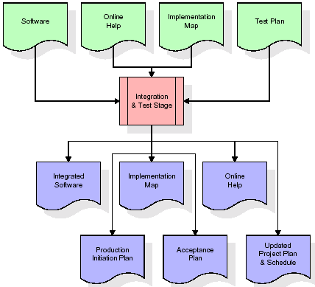
The outputs of the integration and test stage include an integrated set of software, an online help system, an implementation map, a production initiation plan that describes reference data and production users, an acceptance plan which contains the final suite of test cases, and an updated project plan.
- Installation & Acceptance Test:
During the installation and acceptance stage, the software artifacts, online help, and initial production data are loaded onto the production server. At this point, all test cases are run to verify the correctness and completeness of the software. Successful execution of the test suite is a prerequisite to acceptance of the software by the customer.
After customer personnel have verified that the initial production data load is correct and the test suite has been executed with satisfactory results, the customer formally accepts the delivery of the software.
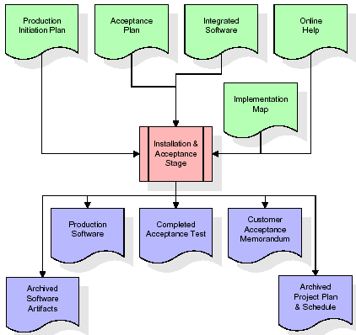
The primary outputs of the installation and acceptance stage include a production application, a completed acceptance test suite, and a memorandum of customer acceptance of the software. Finally, the PDR enters the last of the actual labor data into the project schedule and locks the project as a permanent project record. At this point the PDR "locks" the project by archiving all software items, the implementation map, the source code, and the documentation for future reference.

Maintenance:
Outer rectangle represents maintenance of a project, Maintenance team will start with requirement study, understanding of documentation later employees will be assigned work and they will undergo training on that particular assigned category. For this life cycle there is no end, it will be continued so on like an umbrella (no ending point to umbrella sticks).
3.4. Software Requirement Specification
3.4.1. Overall Description
A Software Requirements Specification (SRS) – a requirements specification for a software system is a complete description of the behavior of a system to be developed. It includes a set of use cases that describe all the interactions the users will have with the software. In addition to use cases, the SRS also contains non-functional requirements. Nonfunctional requirements are requirements which impose constraints on the design or implementation (such as performance engineering requirements, quality standards, or design constraints).
System requirements specification: A structured collection of information that embodies the requirements of a system. A business analyst, sometimes titled system analyst, is responsible for analyzing the business needs of their clients and stakeholders to help identify business problems and propose solutions. Within the systems development lifecycle domain, the BA typically performs a liaison function between the business side of an enterprise and the information technology department or external service providers. Projects are subject to three sorts of requirements:
- Business requirements describe in business terms what must be delivered or accomplished to provide value.
- Product requirements describe properties of a system or product (which could be one of several ways to accomplish a set of business requirements.)
- Process requirements describe activities performed by the developing organization. For instance, process requirements could specify .Preliminary investigation examine project feasibility, the likelihood the system will be useful to the organization. The main objective of the feasibility study is to test the Technical, Operational and Economical feasibility for adding new modules and debugging old running system. All system is feasible if they are unlimited resources and infinite time. There are aspects in the feasibility study portion of the preliminary investigation:
- ECONOMIC FEASIBILITY
A system can be developed technically and that will be used if installed must still be a good investment for the organization. In the economical feasibility, the development cost in creating the system is evaluated against the ultimate benefit derived from the new systems. Financial benefits must equal or exceed the costs. The system is economically feasible. It does not require any addition hardware or software. Since the interface for this system is developed using the existing resources and technologies available at NIC, There is nominal expenditure and economical feasibility for certain.
- Operational Feasibility
Proposed projects are beneficial only if they can be turned out into information system. That will meet the organization’s operating requirements. Operational feasibility aspects of the project are to be taken as an important part of the project implementation. This system is targeted to be in accordance with the above-mentioned issues. Beforehand, the management issues and user requirements have been taken into consideration. So there is no question of resistance from the users that can undermine the possible application benefits. The well-planned design would ensure the optimal utilization of the computer resources and would help in the improvement of performance status.
- TECHNICAL FEASIBILITY
Earlier no system existed to cater to the needs of ‘Secure Infrastructure Implementation System’. The current system developed is technically feasible. It is a web-based user interface for audit workflow at NIC-CSD. Thus, it provides an easy access to. the users. The database’s purpose is to create, establish and maintain a workflow among various entities in order to facilitate all concerned users in their various capacities or roles. Permission to the users would be granted based on the roles specified. Therefore, it provides the technical guarantee of accuracy, reliability and security.
3.4.2. External Interface Requirements
User Interface
The user interface of this system is a user friendly python Graphical User Interface.
Hardware Interfaces
The interaction between the user and the console is achieved through python capabilities.
Software Interfaces
The required software is python.
SYSTEM REQUIREMENT:
HARDWARE REQUIREMENTS:

Processor - Intel i3(min)
- Speed - 1.1 GHz
- RAM - 4GB(min)
- Hard Disk - 500 GB
SOFTWARE REQUIREMENTS:
- Operating System - Windows10(min)
- Programming Language - Python with Jupiter notebook

4. SYSTEM DESIGN
CLASS DIAGRAM:
The class diagram is the main building block of object-oriented modeling. It is used both for general conceptual modeling of the systematic of the application, and for detailed modeling translating the models into programming code. Class diagrams can also be used for data modeling. The classes in a class diagram represent both the main objects, interactions in the application and the classes to be programmed. In the diagram, classes are represented with boxes which contain three parts:
- The upper part holds the name of the class
- The middle part contains the attributes of the class
- The bottom part gives the methods or operations the class can take or undertake

USECASE DIAGRAM:
A use case diagram at its simplest is a representation of a user's interaction with the system and depicting the specifications of a use case. A use case diagram can portray the different types of users of a system and the various ways that they interact with the system. This type of diagram is typically used in conjunction with the textual use case and will often be accompanied by other types of diagrams as we

SEQUENCE DIAGRAM
A sequence diagram is a kind of interaction diagram that shows how processes operate with one another and in what order. It is a construct of a Message Sequence Chart. A sequence diagram shows object interactions arranged in time sequence. It depicts the objects and classes involved in the scenario and the sequence of messages exchanged between the objects needed to carry out the functionality of the scenario. Sequence diagrams are typically associated with use case realizations in the Logical View of the system under development. Sequence diagrams are sometimes called event diagrams, event scenarios, and timing diagrams.

COLLABORATION DIAGRAM:
A collaboration diagram describes interactions among objects in terms of sequenced messages. Collaboration diagrams represent a combination of information taken from class, sequence, and use case diagrams describing both the static structure and dynamic behaviour of a system.

COMPONENT DIAGRAM:
In the Unified Modelling Language, a component diagram depicts how components are wired together to form larger components and or software systems. They are used to illustrate the structure of arbitrarily complex systems.
Components are wired together by using an assembly connector to connect the required interface of one component with the provided interface of another component. This illustrates the service consumer - service provider relationship between the two compo

DEPLOYMENT DIAGRAM:
A deployment diagram in the Unified Modeling Language models the physical deployment of artifacts on nodes. To describe a web site, for example, a deployment diagram would show what hardware components ("nodes") exist (e.g., a web server, an application server, and a database server), what software components ("artifacts") run on each node (e.g., web application, database), and how the different pieces are connected (e.g. JDBC, REST, RMI).
The nodes appear as boxes, and the artifacts allocated to each node appear as rectangles within the boxes. Nodes may have sub nodes, which appear as nested boxes. A single node in a deployment diagram may conceptually represent multiple physical nodes, such as a cluster of database servers.
ACTIVITY DIAGRAM:
Activity diagram is another important diagram in UML to describe dynamic aspects of the system. It is basically a flow chart to represent the flow form one activity to another activity. The activity can be described as an operation of the system. So the control flow is drawn from one operation to another. This flow can be sequential, branched or concurrent

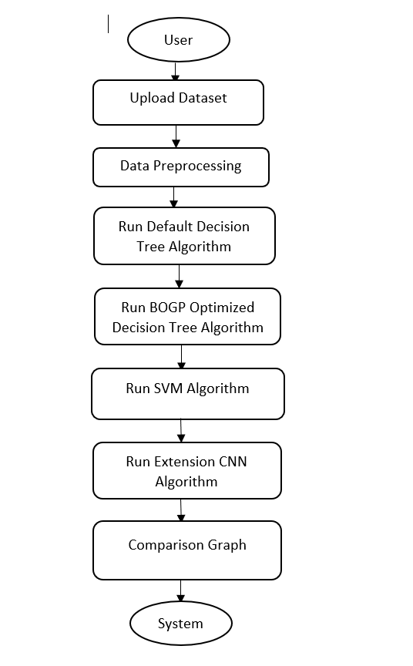

Data flow:
Data flow diagrams illustrate how data is processed by a system in terms of inputs and outputs. Data flow diagrams can be used to provide a clear representation of any business function. The technique starts with an overall picture of the business and continues by analyzing each of the functional areas of interest. This analysis can be carried out in precisely the level of detail required. The technique exploits a method called top-down expansion to conduct the analysis in a targeted way.
As the name suggests, Data Flow Diagram (DFD) is an illustration that explicates the passage of information in a process. A DFD can be easily drawn using simple symbols. Additionally, complicated processes can be easily automated by creating DFDs using easy-to-use, free downloadable diagramming tools. A DFD is a model for constructing and analyzing information processes. DFD illustrates the flow of information in a process depending upon the inputs and outputs. A DFD can also be referred to as a Process Model. A DFD demonstrates business or technical process with the support of the outside data saved, plus the data flowing from the process to another and the end results.
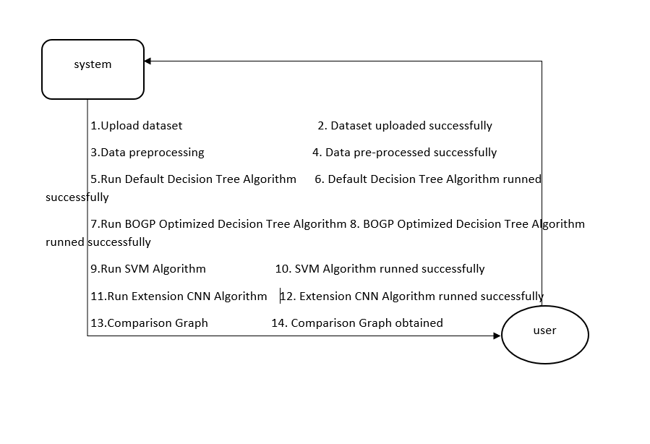

4.IMPLEMENTATION

4.IMPLEMENTATION

4.1 Python
Python is a general-purpose language. It has wide range of applications from Web development (like: Django and Bottle), scientific and mathematical computing (Orange, SymPy, NumPy) to desktop graphical user Interfaces (Pygame, Panda3D). The syntax of the language is clean and length of the code is relatively short. It's fun to work in Python because it allows you to think about the problem rather than focusing on the syntax.
History of Python:
Python is a fairly old language created by Guido Van Rossum. The design began in the late 1980s and was first released in February 1991.
Why Python was created?
In late 1980s, Guido Van Rossum was working on the Amoeba distributed operating system group. He wanted to use an interpreted language like ABC (ABC has simple easy-to-understand syntax) that could access the Amoeba system calls. So, he decided to create a language that was extensible. This led to design of a new language which was later named Python.
Why the name Python?
No. It wasn't named after a dangerous snake. Rossum was fan of a comedy series from late seventies. The name "Python" was adopted from the same series "Monty Python's Flying Circus".
Features of Python:
A simple language which is easier to learn
Python has a very simple and elegant syntax. It's much easier to read and write Python programs compared to other languages like: C++, Java, C#. Python makes programming fun and allows you to focus on the solution rather than syntax.
If you are a newbie, it's a great choice to start your journey with Python.
Free and open-source
You can freely use and distribute Python, even for commercial use. Not only can you use and distribute software’s written in it, you can even make changes to the Python's source code.
Python has a large community constantly improving it in each iteration.
Portability
You can move Python programs from one platform to another, and run it without any changes.
It runs seamlessly on almost all platforms including Windows, Mac OS X and Linux.
Extensible and Embeddable
Suppose an application requires high performance. You can easily combine pieces of C/C++ or other languages with Python code.
This will give your application high performance as well as scripting capabilities which other languages may not provide out of the box.
A high-level, interpreted language
Unlike C/C++, you don't have to worry about daunting tasks like memory management, garbage collection and so on.
Likewise, when you run Python code, it automatically converts your code to the language your computer understands. You don't need to worry about any lower-level operations.
Large standard libraries to solve common tasks
Python has a number of standard libraries which makes life of a programmer much easier since you don't have to write all the code yourself. For example: Need to connect MySQL database on a Web server? You can use MySQL dB library using import MySQL db.
Standard libraries in Python are well tested and used by hundreds of people. So, you can be sure that it won't break your application.
Object-oriented
Everything in Python is an object. Object oriented programming (OOP) helps you solve a complex problem intuitively.
With OOP, you are able to divide these complex problems into smaller sets by creating objects.
Applications of Python:
1. Simple Elegant Syntax
Programming in Python is fun. It's easier to understand and write Python code. Why? The syntax feels natural. Take this source code for an example:
a = 2
b = 3
sum = a + b
print(sum)
2. Not overly strict
You don't need to define the type of a variable in Python. Also, it's not necessary to add semicolon at the end of the statement.
Python enforces you to follow good practices (like proper indentation). These small things can make learning much easier for beginners.
3. Expressiveness of the language
Python allows you to write programs having greater functionality with fewer lines of code. Here's a link to the source code of Tic-tac-toe game with a graphical interface and a smart computer opponent in less than 500 lines of code. This is just an example. You will be amazed how much you can do with Python once you learn the basics.
4. Great Community and Support
Python has a large supporting community. There are numerous active forums online which can be handy if you are stuck.
5.2 Sample Code:
import pandas as pd
import numpy as np
from bayes_opt import BayesianOptimization #importing byaseian optimization class
import matplotlib. pyplot as plt #use to visualize dataset values
import seaborn as sns
from sklearn.preprocessing import MinMaxScaler
from sklearn.model_selection import train_test_split
from sklearn.tree import DecisionTreeClassifier
from sklearn.metrics import precision_score
from sklearn.metrics import recall_score
from sklearn.metrics import f1_score
from sklearn.metrics import accuracy_score
from sklearn.metrics import confusion_matrix
from sklearn.metrics import roc_curve
from sklearn.metrics import roc_auc_score
from sklearn import metrics
from sklearn.preprocessing import LabelEncoder
from imblearn.over_sampling import SMOTE#loading SMOTE class to deal with imbalance data
from sklearn.decomposition import PCA
from sklearn.model_selection import cross_val_score
from sklearn import svm
import os
from keras.utils.np_utils import to_categorical
from keras.layers import MaxPooling2D

from keras.layers import Dense, Dropout, Activation, Flatten, GlobalAveragePooling2D, BatchNormalization
from keras.layers import Convolution2D
from keras.models import Sequential
from keras.callbacks import ModelCheckpoint
import pickle
dataset = pd.read_csv("Dataset/UNSW_2018_IoT_Botnet_Full5pc_4.csv", low_memory=False)
dataset
labels, count = np.unique(dataset['attack'].ravel(), return_counts = True)
print("Normal Records : "+str(count[0]))
print("Attack Records : "+str(count[1]))
height = count
bars = labels
y_pos = np.arange(len(bars))
plt.figure(figsize = (4, 3))
plt.bar(y_pos, height)
plt.xticks(y_pos, bars)
plt.xlabel("Dataset Class Label Graph")
plt.ylabel("Count")
plt.xticks(rotation=90)
plt.show()
dataset.isnull().sum()
dataset.groupby("proto").size().plot.pie(autopct='%.0f%%', figsize=(6, 6))
plt.title("Different Protocol Graph")
plt.xlabel("Protocol Name")
plt.ylabel("Usage %")
plt.show()
data = dataset[['proto', 'attack']]
plt.figure(figsize=(6,4))
sns.boxplot(data=data, x='proto', y='attack', palette='rainbow')
plt.title("Different Protocols Used by Attacks")
plt.show()
dataset.drop(['pkSeqID', 'category', 'subcategory'], axis = 1,inplace=True)
#using label encoder to convert non-numeric values to numeric values
encoder1 = LabelEncoder()
encoder2 = LabelEncoder()
encoder3 = LabelEncoder()
encoder4 = LabelEncoder()
encoder5 = LabelEncoder()
encoder6 = LabelEncoder()
encoder7 = LabelEncoder()
dataset['flgs'] = pd.Series(encoder1.fit_transform(dataset['flgs'].astype(str)))#encode all str columns to numeric
dataset['proto'] = pd.Series(encoder2.fit_transform(dataset['proto'].astype(str)))#encode all str columns to numeric
dataset['saddr'] = pd.Series(encoder3.fit_transform(dataset['saddr'].astype(str)))#encode all str columns to numeric
dataset['sport'] = pd.Series(encoder4.fit_transform(dataset['sport'].astype(str)))#encode all str columns to numeric
dataset['daddr'] = pd.Series(encoder5.fit_transform(dataset['daddr'].astype(str)))#encode all str columns to numeric
dataset['dport'] = pd.Series(encoder6.fit_transform(dataset['dport'].astype(str)))#encode all str columns to numeric
dataset['state'] = pd.Series(encoder7.fit_transform(dataset['state'].astype(str)))#encode all str columns to numeric
dataset
pca = PCA(n_components=2)
temp = dataset.values
X = temp[:,0:temp.shape[1]-1]
Y = temp[:,temp.shape[1]-1]
X = pca.fit_transform(X)
plt.figure(figsize=(6,4))
plt.scatter(X[:, 0], X[:, 1], c=Y)
plt.xlabel("First Principal Component")
plt.ylabel("Second Principal Component")
plt.title("Dataset Imbalance Graph")
plt.show()
Y = dataset['attack'].ravel()#represents attack or normal
data = dataset.values
X = data[:,0:dataset.shape[1]-1]
indices = np.arange(X.shape[0])
np.random.shuffle(indices)#shuffling dataset values
X = X[indices]
Y = Y[indices]
thr = 50
#normalizing dataset values using min max scaler
scaler = MinMaxScaler(feature_range = (0, 1))
X = scaler.fit_transform(X)#normalize train features
print("Normalize Training Features")
print(X)
#now apply smote algorithm on imbalance dataset for balancing
smote = SMOTE()
X, Y = smote.fit_resample(X, Y)
#dataset class labels after applying smote
labels, count = np.unique(Y, return_counts = True)
print("Normal Records After Smote : "+str(count[0]))
print("Attack Records After Smote: "+str(count[1]))
height = count
bars = ['Normal', 'Attack']
y_pos = np.arange(len(bars))
plt.figure(figsize = (4, 3))
plt.bar(y_pos, height)
plt.xticks(y_pos, bars)
plt.xlabel("Dataset Class Label Graph After Applying SMOTE")
plt.ylabel("Count")
plt.xticks(rotation=90)
plt.show()
#split dataset into train and test
X_train, X_test, y_train, y_test = train_test_split(X, Y, test_size = 0.2)
print("Total records found in dataset = "+str(X.shape[0]))
print("Total features found in dataset= "+str(X.shape[1]))
print("80% dataset for training : "+str(X_train.shape[0]))
print("20% dataset for testing : "+str(X_test.shape[0]))
#define global variables to save accuracy and other metrics
accuracy = []
precision = []
recall = []
fscore = []
#function to calculate all metrics
def calculateMetrics(algorithm, testY, predict):
p = precision_score(testY, predict,average='macro') * 100
r = recall_score(testY, predict,average='macro') * 100
f = f1_score(testY, predict,average='macro') * 100
a = accuracy_score(testY,predict)*100
accuracy.append(a)
precision.append(p)
recall.append(r)
fscore.append(f)
print(algorithm+" Accuracy : "+str(a))
print(algorithm+" Precision : "+str(p))
print(algorithm+" Recall : "+str(r))
print(algorithm+" FSCORE : "+str(f))
labels = ['Normal', 'Attack']
conf_matrix = confusion_matrix(testY, predict)
fig, axs = plt.subplots(1,2,figsize=(10, 3))
ax = sns.heatmap(conf_matrix, xticklabels = labels, yticklabels = labels, annot = True, cmap="viridis" ,fmt ="g", ax=axs[0]);
ax.set_ylim([0,len(labels)])
axs[0].set_title(algorithm+" Confusion matrix")

random_probs = [0 for i in range(len(testY))]
p_fpr, p_tpr, _ = roc_curve(testY, random_probs, pos_label=1)
plt.plot(p_fpr, p_tpr, linestyle='--', color='orange',label="True classes")
ns_fpr, ns_tpr, _ = roc_curve(testY, predict, pos_label=1)
axs[1].plot(ns_fpr, ns_tpr, linestyle='--', label='Predicted Classes')
axs[1].set_title(algorithm+" ROC AUC Curve")
axs[1].set_xlabel('False Positive Rate')
axs[1].set_ylabel('True Positive rate')
plt.show()
#training and evaluating performance of default decision tree algorithm
dt_cls = DecisionTreeClassifier(max_depth=1)
dt_cls.fit(X_train, y_train)#train algorithm using training features and target value
predict =dt_cls.predict(X_test)#perform prediction on test data
#call this function with true and predicted values to calculate accuracy and other metrics
calculateMetrics("Default Decision Tree Algorithm", y_test, predict)
def gaussianProcess(max_depth, min_samples_split, max_features):
params_dt = {}
params_dt['max_depth'] = max_depth
params_dt['min_samples_split'] = min_samples_split
params_dt['max_features'] = max_features
scores = cross_val_score(DecisionTreeClassifier(random_state=123, **params_dt),
X_train, y_train, cv=5).mean()
score = scores.mean()
return score
params_dt = {'max_depth':(5, 10), 'min_samples_split':(0.1, 0.9), 'max_features':(0.1, 0.9)}
dt_bo = BayesianOptimization(gaussianProcess, params_dt, random_state=111)
dt_bo.maximize(init_points=5, n_iter=2)
params_dt = dt_bo.max['params']
print("Best Optimized Parameters Selected by BOGP = "+str(params_dt))
#training and evaluating performance of BOGP optimizied decision tree algorithm
bogp_dt_cls = DecisionTreeClassifier(max_depth=params_dt['max_depth'], max_features=params_dt['max_features'],
min_samples_split=params_dt['min_samples_split'])
bogp_dt_cls.fit(X_train, y_train)#train algorithm using training features and target value
predict = bogp_dt_cls.predict(X_test)#perform prediction on test data
#call this function with true and predicted values to calculate accuracy and other metrics
calculateMetrics("BOGP Optimized Decision Tree", y_test, predict)
#training and evaluating performance of SVM algorithm
svm_cls = svm.SVC()
svm_cls.fit(X_train[0:thr], y_train[0:thr])#train algorithm using training features and target value
predict = svm_cls.predict(X_test) #perform prediction on test data
#call this function with true and predicted values to calculate accuracy and other metrics
calculateMetrics("SVM Algorithm", y_test, predict)
#training CNN deep learning algorithm to predict factory maintenaance
#converting dataset shape for CNN comptaible format as 4 dimension array
X_train1 = np.reshape(X_train, (X_train.shape[0], X_train.shape[1], 1, 1))
X_test1 = np.reshape(X_test, (X_test.shape[0], X_test.shape[1], 1, 1))
y_train1 = to_categorical(y_train)
y_test1 = to_categorical(y_test)
#creating deep learning cnn model object
cnn_model = Sequential()
#defining CNN layer wwith 32 neurons of size 1 X 1 to filter dataset features 32 times
cnn_model.add(Convolution2D(32, (1 , 1), input_shape = (X_train1.shape[1], X_train1.shape[2], X_train1.shape[3]), activation = 'relu'))
#defining maxpool layet to collect relevant filtered features from previous CNN layer
cnn_model.add(MaxPooling2D(pool_size = (1, 1)))
#creating another CNN layer with 16 neurons to optimzed features 16 times
cnn_model.add(Convolution2D(16, (1, 1), activation = 'relu'))
#max layet to collect relevant features
cnn_model.add(MaxPooling2D(pool_size = (1, 1)))
#convert multidimension features to single flatten size
cnn_model.add(Flatten())
#define output prediction layer
cnn_model.add(Dense(units = 256, activation = 'relu'))
cnn_model.add(Dense(units = y_train1.shape[1], activation = 'softmax'))
#compile, train and load CNN model
cnn_model.compile(optimizer = 'adam', loss = 'categorical_crossentropy', metrics = ['accuracy'])
if os.path.exists("model/cnn_weights.hdf5") == False:
model_check_point = ModelCheckpoint(filepath='model/cnn_weights.hdf5', verbose = 1, save_best_only = True)
hist = cnn_model.fit(X_train1, y_train1, batch_size = 32, epochs = 5, validation_data=(X_test1, y_test1), callbacks=[model_check_point], verbose=1)
f = open('model/cnn_history.pckl', 'wb')
pickle.dump(hist.history, f)
f.close()
else:
cnn_model.load_weights("model/cnn_weights.hdf5")
#perform prediction on test data
predict = cnn_model.predict(X_test1)
predict = np.argmax(predict, axis=1)
y_test1 = np.argmax(y_test1, axis=1)
#call this function to calculate accuracy and other metrics
calculateMetrics("Extension CNN", y_test1, predict)
#comparison graph between all algorithms
df = pd.DataFrame([['Default Decision Tree','Accuracy',accuracy[0]],['Default Decision Tree','Precision',precision[0]],['Default Decision Tree','Recall',recall[0]],['Default Decision Tree','FSCORE',fscore[0]],
['Optimized Decision Tree','Accuracy',accuracy[1]],['Optimized Decision Tree','Precision',precision[1]],['Optimized Decision Tree','Recall',recall[1]],['Optimized Decision Tree','FSCORE',fscore[1]],
['SVM','Accuracy',accuracy[2]],['SVM','Precision',precision[2]],['SVM','Recall',recall[2]],['SVM','FSCORE',fscore[2]],
['Extension CNN','Accuracy',accuracy[3]],['Extension CNN','Precision',precision[3]],['Extension CNN','Recall',recall[3]],['Extension CNN','FSCORE',fscore[3]],
],columns=['Parameters','Algorithms','Value'])
df.pivot("Parameters", "Algorithms", "Value").plot(kind='bar', figsize=(6, 3))
plt.title("All Algorithms Performance Graph")
plt.show()
#display all algorithm performnace
algorithms = ['Default Decision Tree', 'Optimized Decision Tree', 'SVM', 'Extension CNN']
data = []
for i in range(len(accuracy)):
data.append([algorithms[i], accuracy[i], precision[i], recall[i], fscore[i]])
data = pd.DataFrame(data, columns=['Algorithm Name', 'Accuracy', 'Precision', 'Recall', 'FSCORE'])
data

5.RESULT & DISCUSSION

5.RESULT & DISCUSSION

SCREENSHOTS:
We have coded this project using JUPYTER notebook and below are the code and output screen with blue colour comments
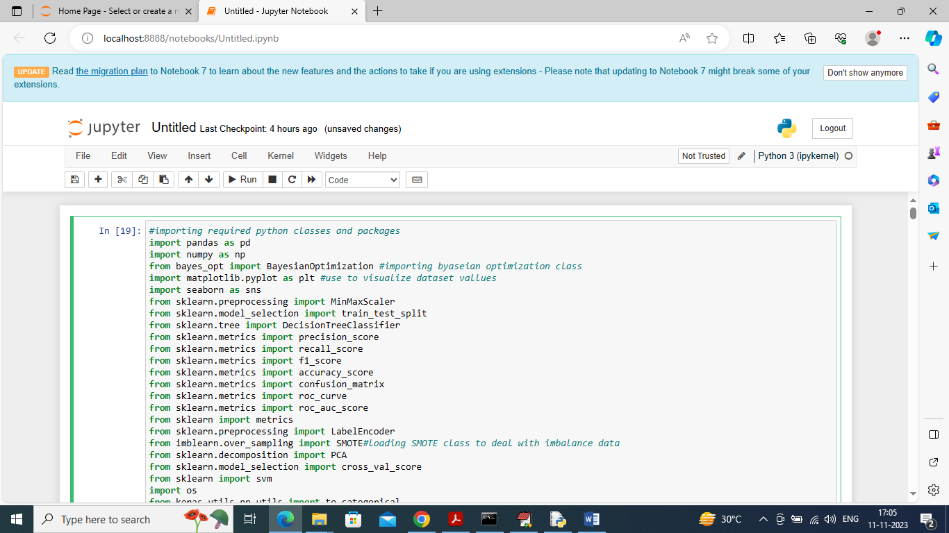
In above screen importing required python classes and packages
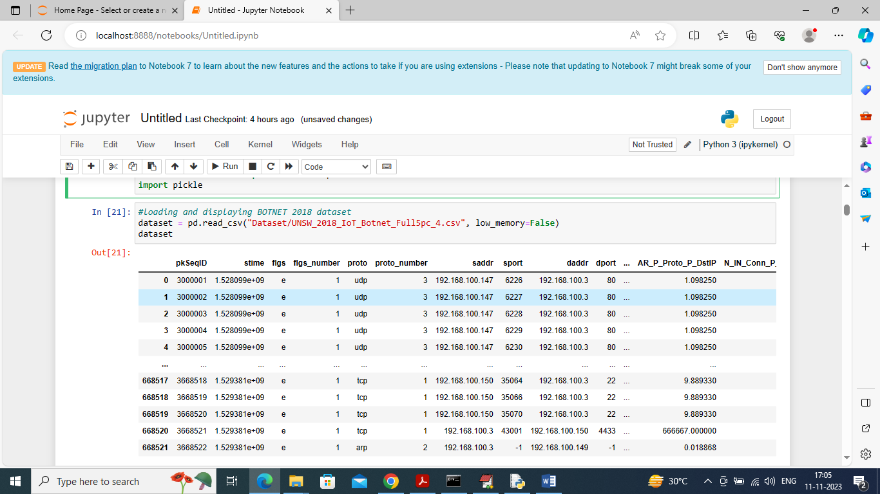
In above screen loading and displaying BOTNET2018 dataset values and in above dataset we have both numeric and non-numeric values but ML algorithms take only numeric data so later by applying processing techniques will convert non-numeric values to numeric values
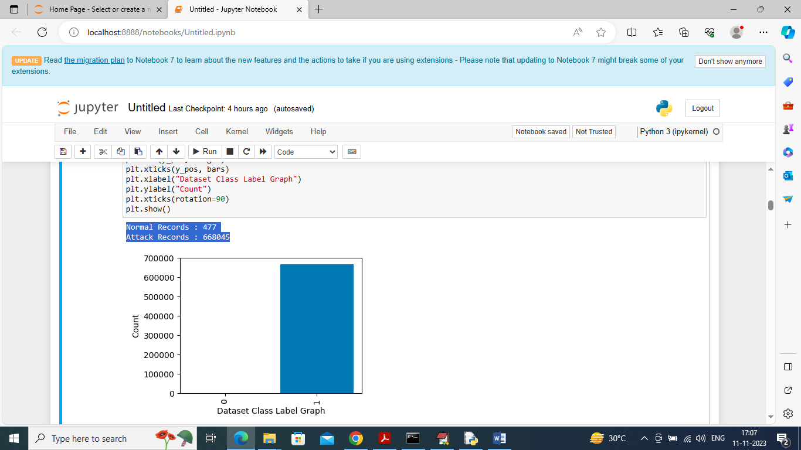
In above screen displaying number of NORMAL and ATTACK records found in dataset and in above blue colour text can see Normal contains only 477 records and attack contains records in lakhs and in graph also we can see only attack records are more so this dataset is highly imbalance and we can balance by applying SMOTE technique
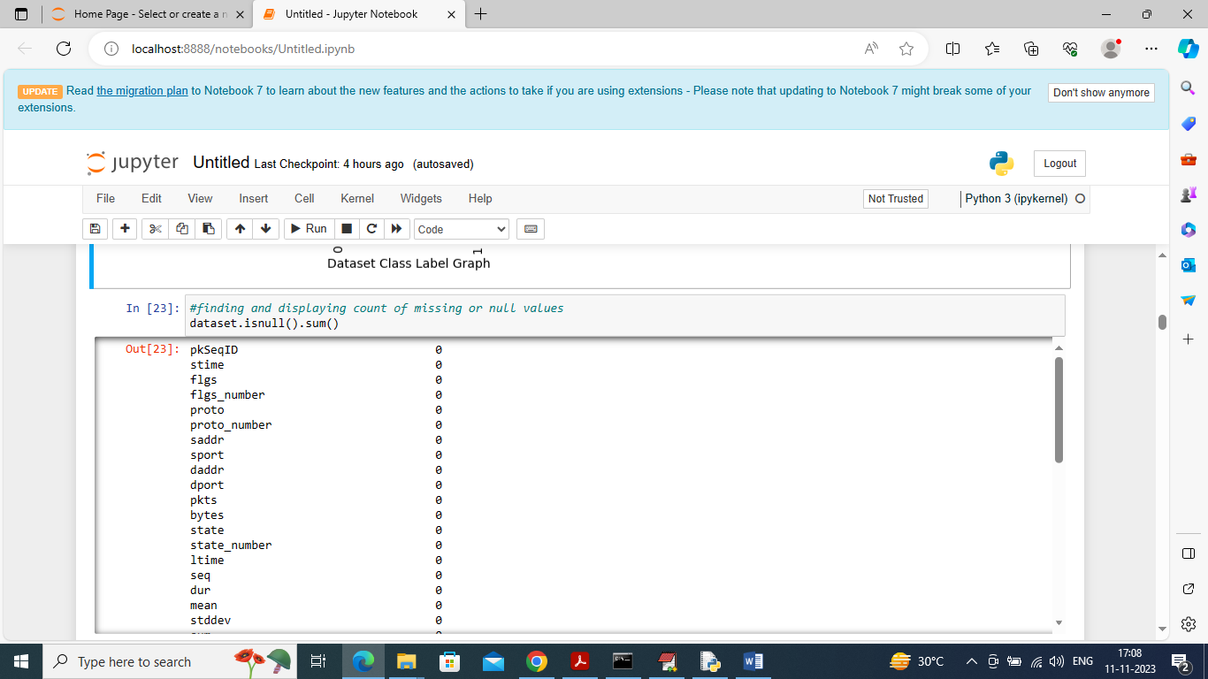
In above screen finding and checking count of missing values but this dataset contains NO missing values
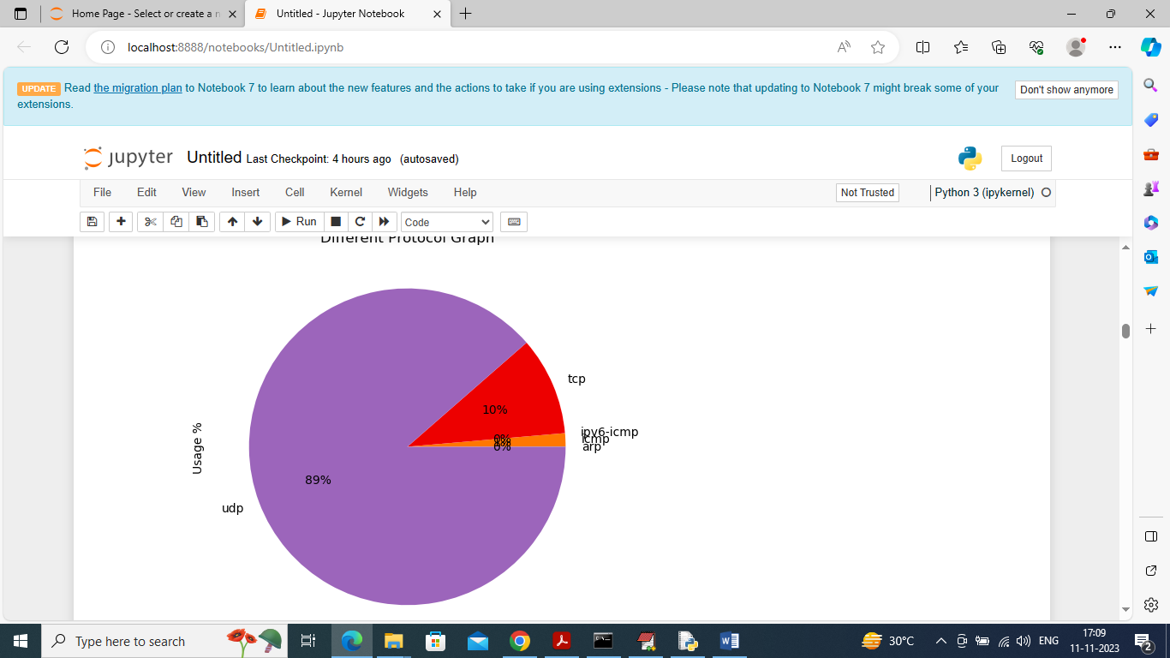
In above graph displaying percentage of different protocols used in this dataset and from above graph can say 89% is usage of UDP protocol
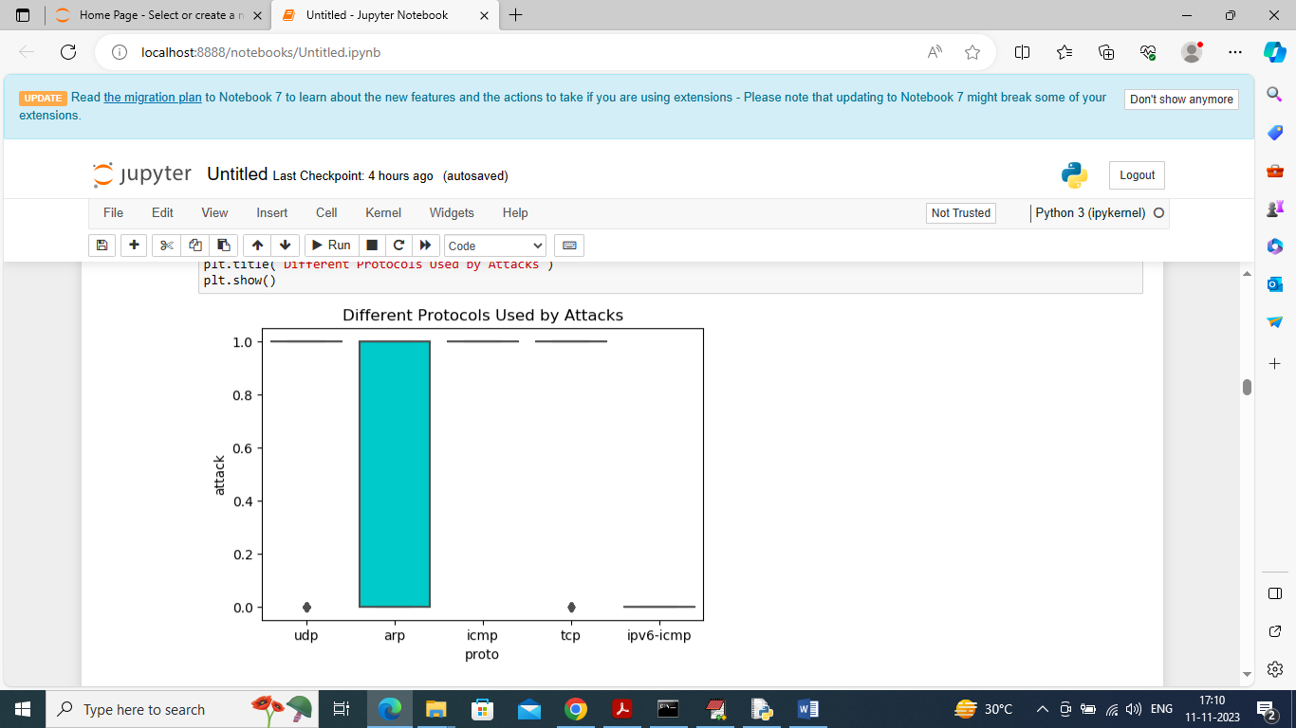
In above graph finding different protocols uses by attacks and in above graph x-axis represents Protocol Type and y-axis represents usage %
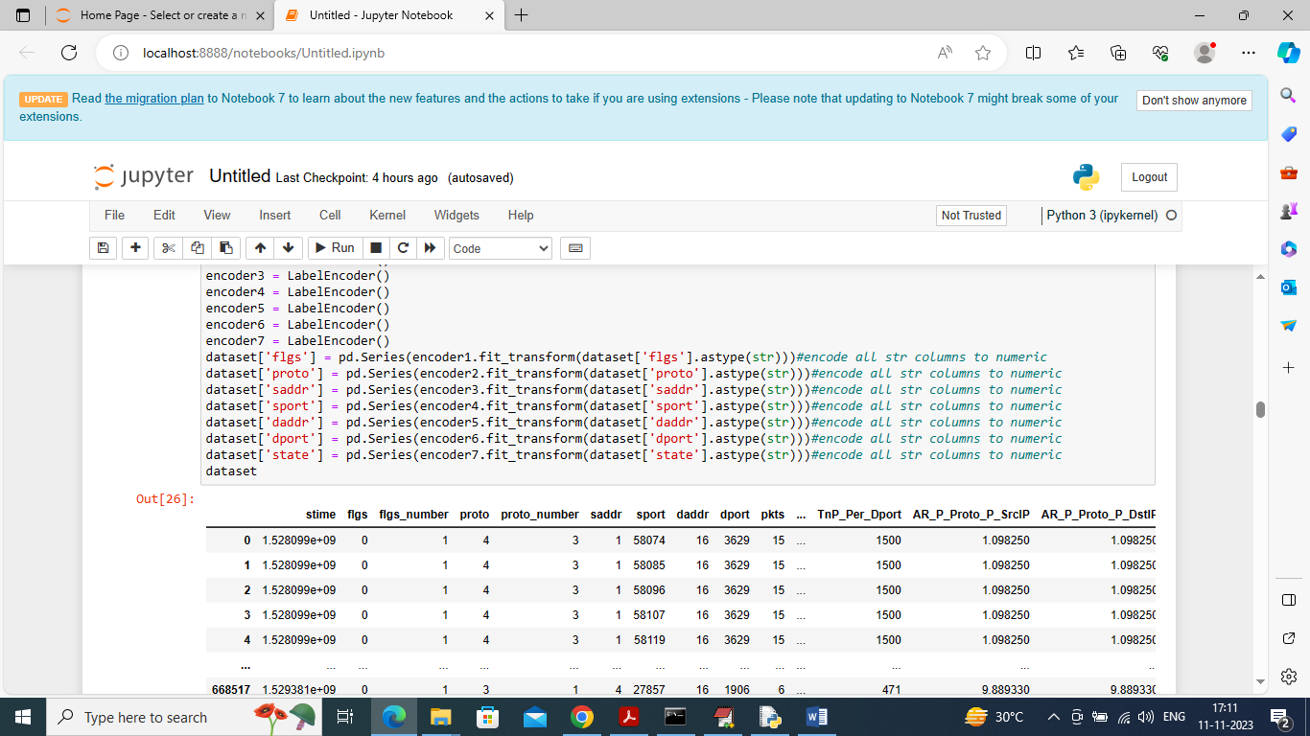
In above screen by applying Label Encoder class we are converting non-numeric values into numeric values and then displaying all numeric data
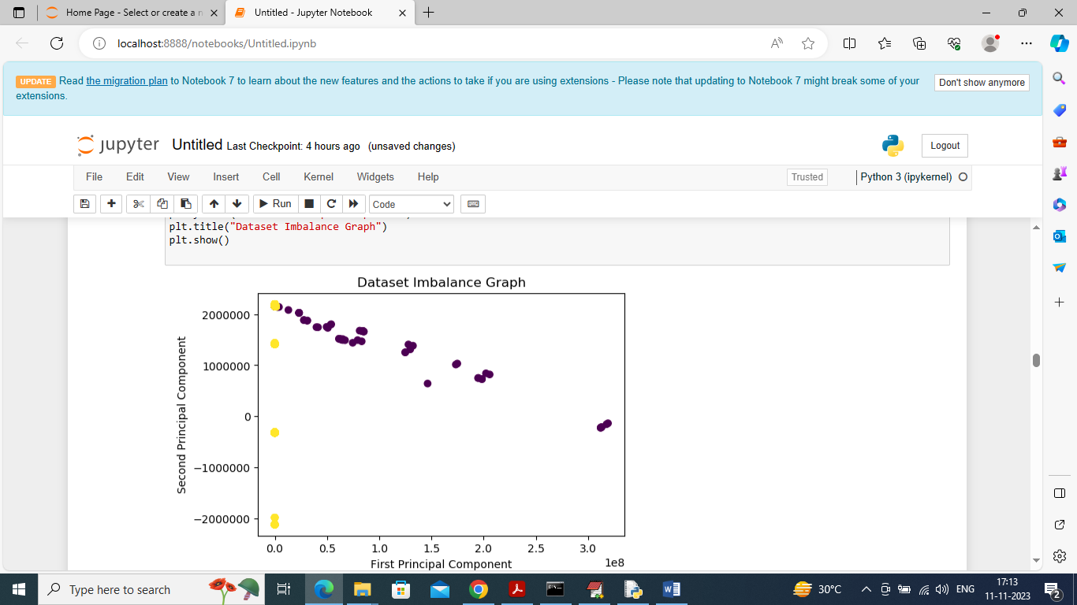
In above screen displaying dataset imbalance ratio where blue dots are for ATTACKS and yellow dots for Normal records and can see there are so many blue dots and yellow dots are very few so this dataset is highly imbalance
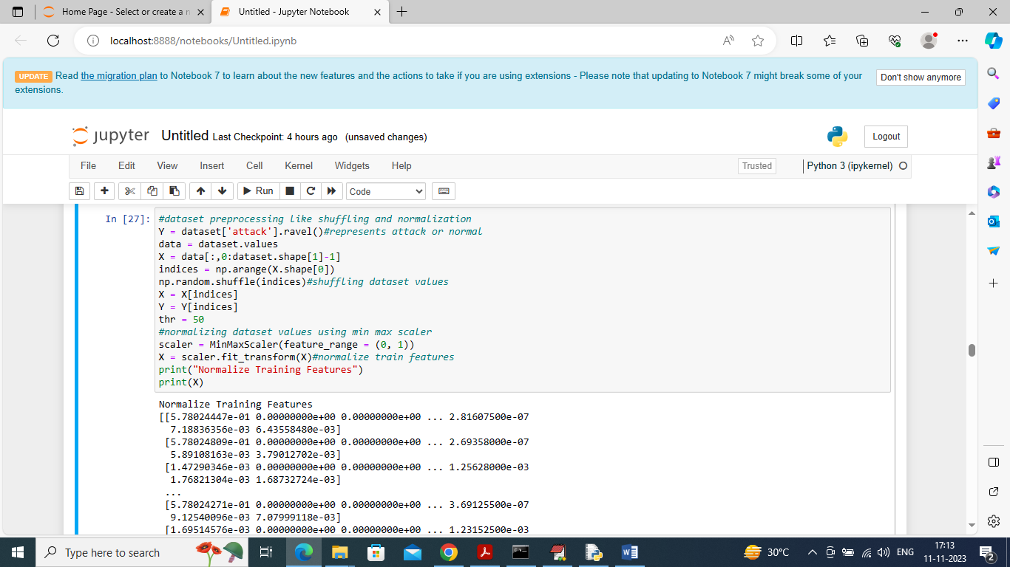
In above screen applying various pre-processing techniques such as shuffling and normalizing dataset using MINMAX scaling and then displaying normalized values
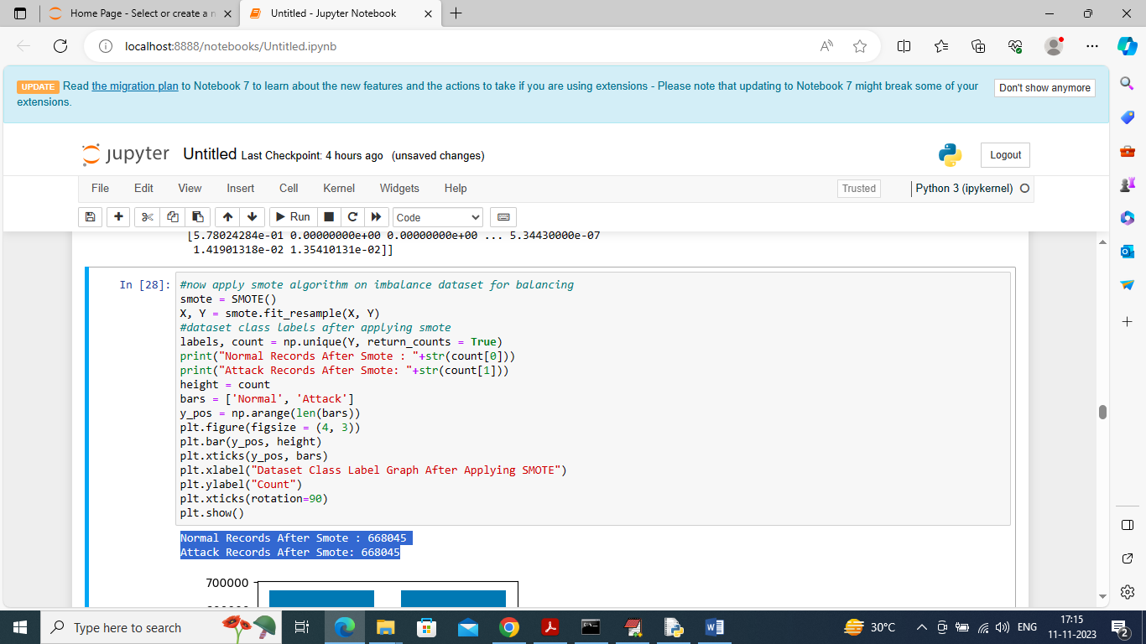
In above screen applying SMOTE algorithm on processed dataset and in blue colour text can see both normal and attacks records size are equal and now dataset is balance
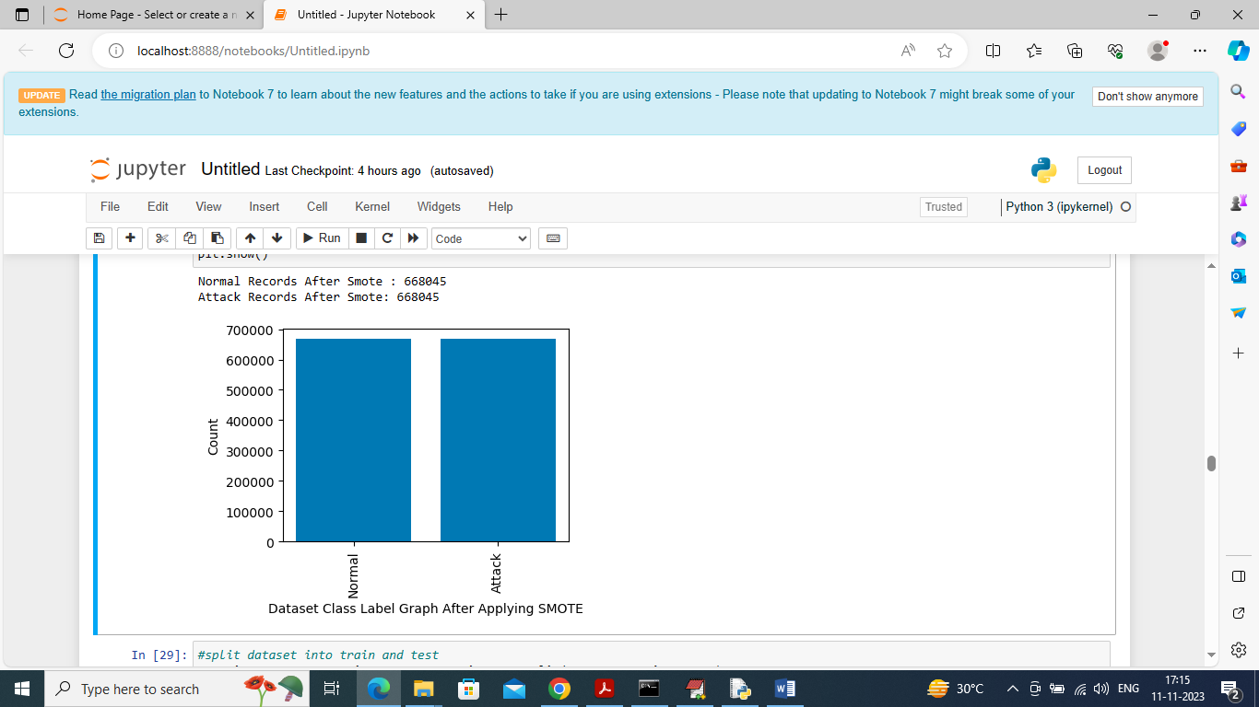
After applying SMOTE in above graph can see both class labels are having equal number of records
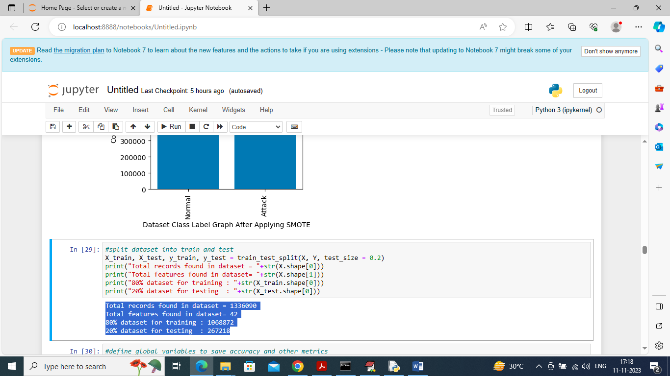
In above screen splitting dataset into train and test where application using 80% dataset for training and 20% for testing
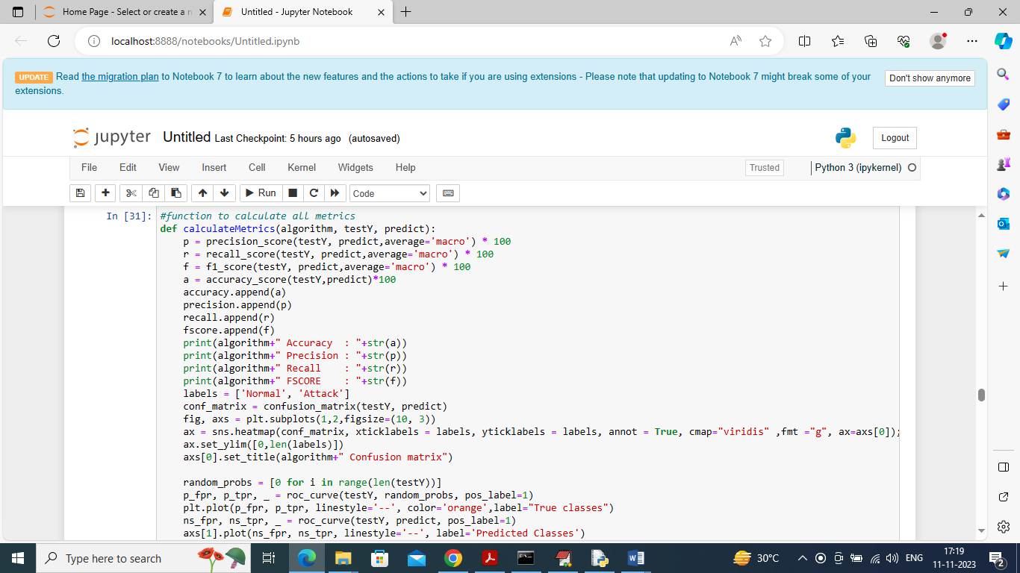
In above screen defining function to calculate accuracy and other metrics
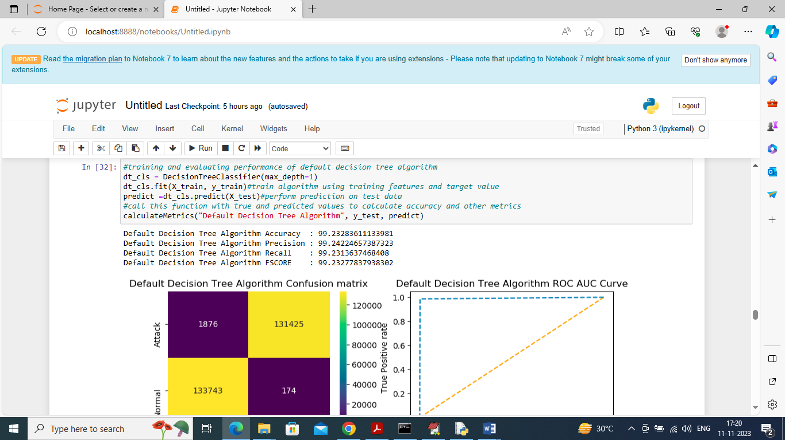
In above screen training Default Decision Tree algorithm and its 99.23% as the accuracy and can see other metrics also. In above confusion matrix graph x-axis represents “Predicted Labels” and y-axis represents “True Labels” and all different yellow boxes in diagnol represents correct prediction count and remaining all blue boxes contains incorrect prediction count which are very few. In Roc curve graph x-axis represents False Positive Rate and y-axis represents True Positive Rate and if blue line goes below orange line then all predictions are incorrect and if goes above orange line then all predictions are correct and in above ROC graph we can see all predictions are correct up to 100%
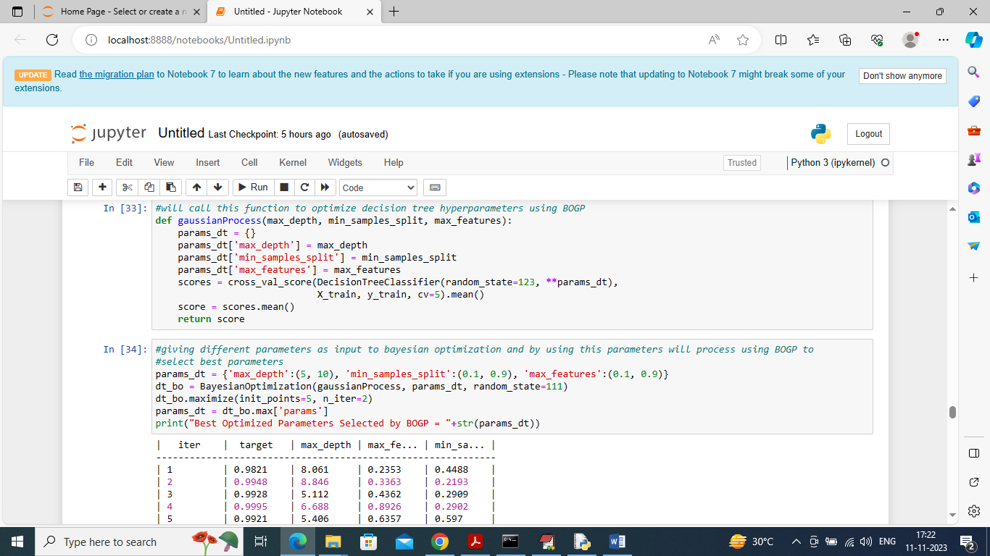
In above screen defining Gaussian Process and optimization function called BOGP with various parameters and then in output in tabular format we can see Target as the accuracy. BOGP will iterate with various parameters values and then trained and calculate accuracy and this will continue till no more enhancement left. In above table we can see for each iteration we can see Target accuracy and used Parameters values and in last will get below ‘Optimized Parameter’
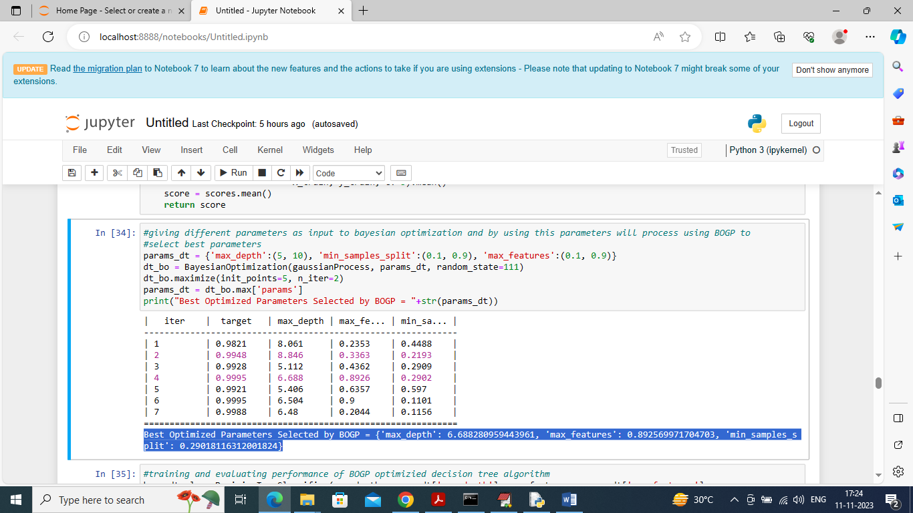
In above screen in blue colour text can see optimized parameters with highest Target values is selected as best parameters and now in optimized decision Tree will use above parameters
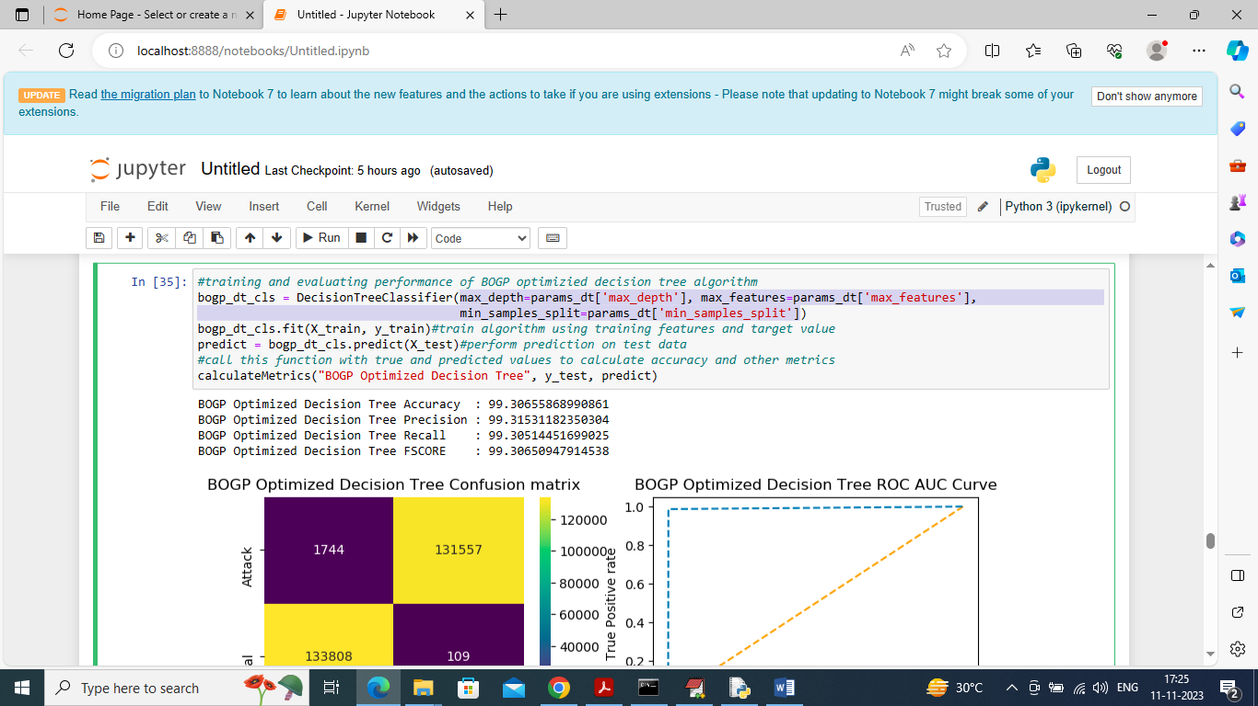
In above screen in light blue text can see that we are training decision tree with best selected BOGP parameters and after training optimized decision tree got 99.30% accuracy which is higher than default decision tree and can see other metrics values
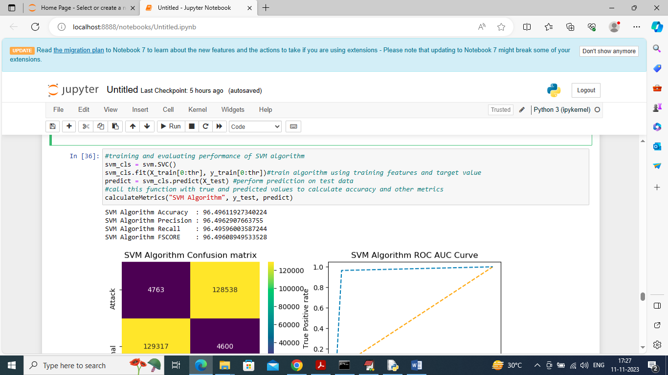
In above screen training existing SVM algorithm and it got 96% accuracy
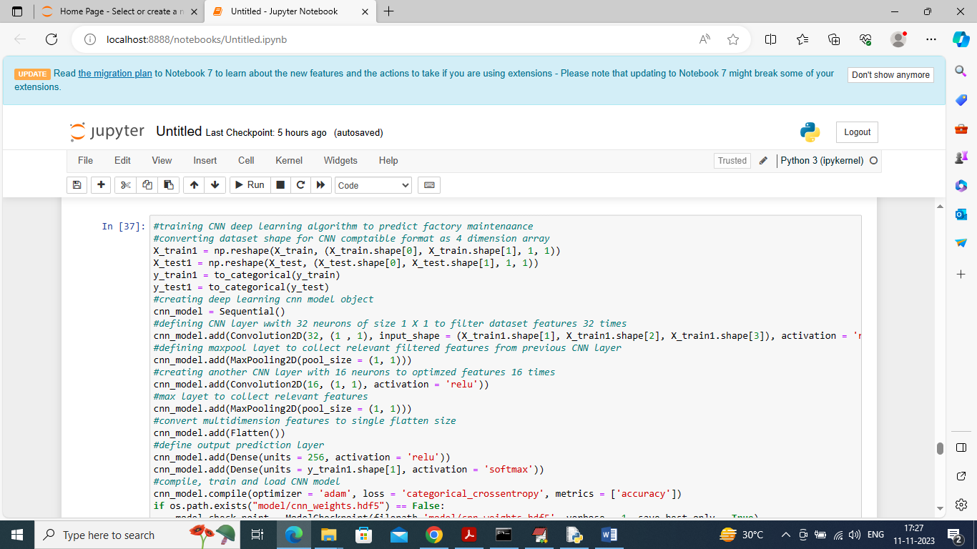
In above screen training deep learning extension CNN algorithm and after executing above block will get below output
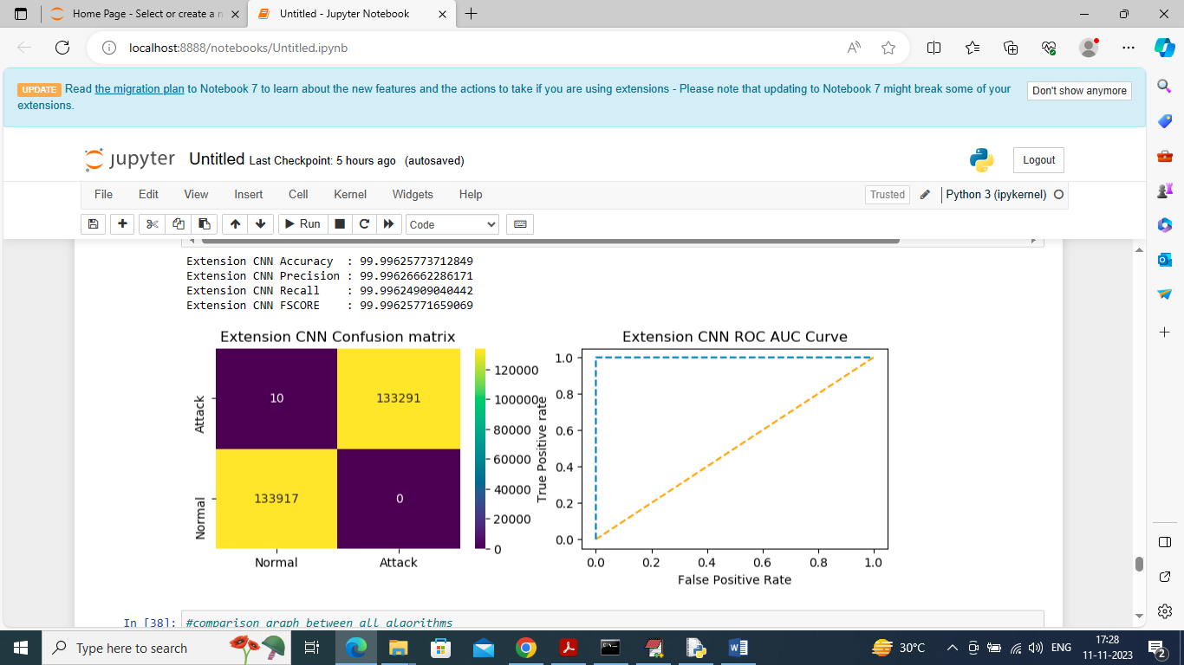
In above screen extension CNN got 99.996% accuracy
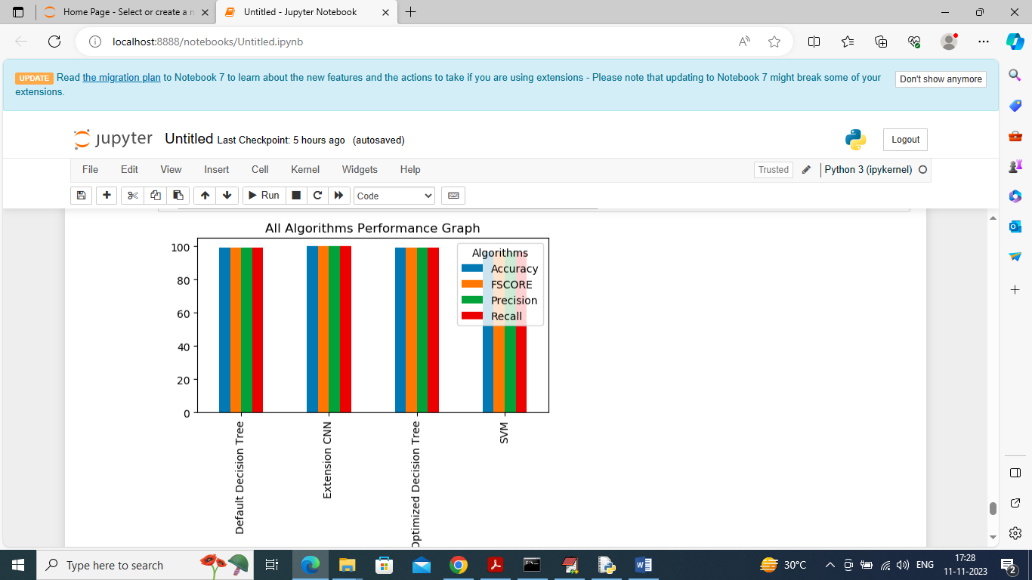
In above graph displaying all algorithm performance where x-axis represents algorithm names and y-axis represents accuracy and other metrics in different color bars and in all algorithms extension CNN got high performance
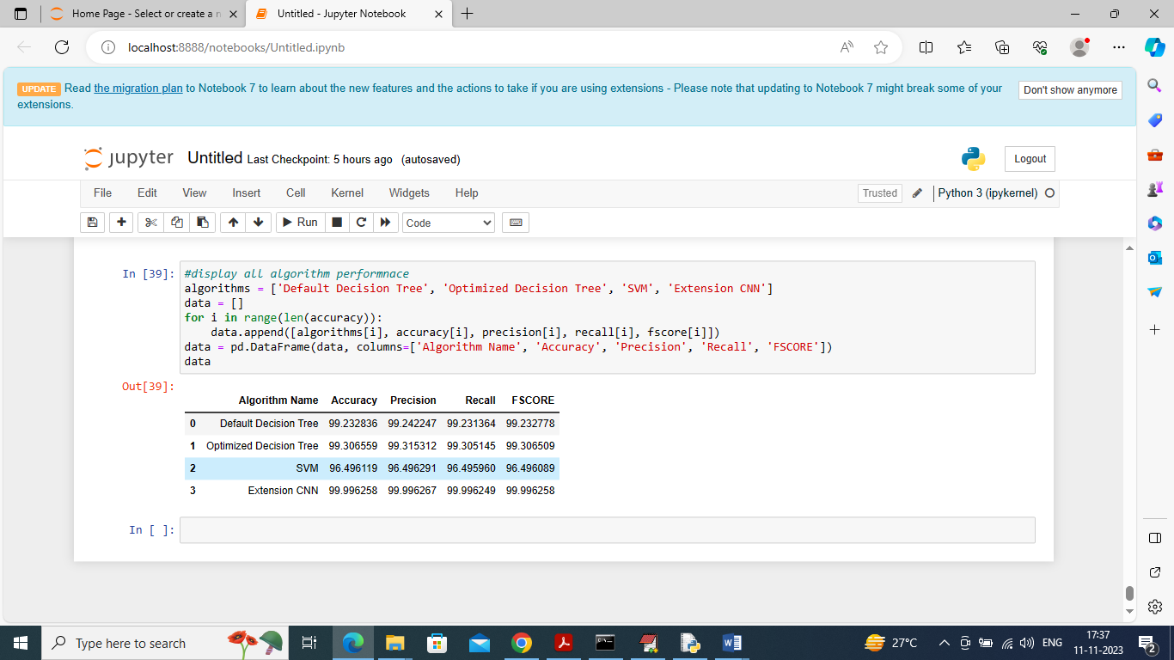
In above screen displaying all algorithm performance in tabular format and in all algorithms can see extension CNN got high performance

6.VALIDATION

6.VALIDATION

TESTING:
Implementation and Testing:
Implementation is one of the most important tasks in project is the phase in which one has to be cautions because all the efforts undertaken during the project will be very interactive. Implementation is the most crucial stage in achieving successful system and giving the users confidence that the new system is workable and effective. Each program is tested individually at the time of development using the sample data and has verified that these programs link together in the way specified in the program specification. The computer system and its environment are tested to the satisfaction of the user.
Implementation
The implementation phase is less creative than system design. It is primarily concerned with user training, and file conversion. The system may be requiring extensive user training. The initial parameters of the system should be modifying as a result of a programming. A simple operating procedure is provided so that the user can understand the different functions clearly and quickly. The different reports can be obtained either on the inkjet or dot matrix printer, which is available at the disposal of the user. The proposed system is very easy to implement. In general implementation is used to mean the process of converting a new or revised system design into an operational one.

Testing
Testing is the process where the test data is prepared and is used for testing the modules individually and later the validation given for the fields. Then the system testing takes place which makes sure that all components of the system property functions as a unit. The test data should be chosen such that it passed through all possible condition. Actually, testing is the state of implementation which aimed at ensuring that the system works accurately and efficiently before the actual operation commence. The following is the description of the testing strategies, which were carried out during the testing period.

System Testing
Testing has become an integral part of any system or project especially in the field of information technology. The importance of testing is a method of justifying, if one is ready to move further, be it to be check if one is capable to with stand the rigors of a particular situation cannot be underplayed and that is why testing before development is so critical. When the software is developed before it is given to user to use the software must be tested whether it is solving the purpose for which it is developed. This testing involves various types through which one can ensure the software is reliable. The program was tested logically and pattern of execution of the program for a set of data are repeated. Thus the code was exhaustively checked for all possible correct data and the outcomes were also checked.
Module Testing
To locate errors, each module is tested individually. This enables us to detect error and correct it without affecting any other modules. Whenever the program is not satisfying the required function, it must be corrected to get the required result. Thus, all the modules are individually tested from bottom up starting with the smallest and lowest modules and proceeding to the next level. Each module in the system is tested separately. For example, the job classification module is tested separately. This module is tested with different job and its approximate execution time and the result of the test is compared with the results that are prepared manually. The comparison shows that the results proposed system works efficiently than the existing system. Each module in the system is tested separately. In this system the resource classification and job scheduling modules are tested separately and their corresponding results are obtained which reduces the process waiting time.
Integration Testing
After the module testing, the integration testing is applied. When linking the modules there may be chance for errors to occur, these errors are corrected by using this testing. In this system all modules are connected and tested. The testing results are very correct. Thus, the mapping of jobs with resources is done correctly by the system.

Acceptance Testing
When that user fined no major problems with its accuracy, the system passers through a final acceptance test. This test confirms that the system needs the original goals, objectives and requirements established during analysis without actual execution which elimination wastage of time and money acceptance tests on the shoulders of users and management, it is finally acceptable and ready for the operation.

Test Case Id | Test Case Name | Test Case Desc. | Test Steps |  |  |  | Test Case Status | Test Priority
 |  |  | Step | Expected |  | Actual
01 | Upload dataset | Verify dataset loaded or not | If dataset may not uploaded | we cannot do any further operations | we can do further operations |  | High | High
02 | Preprocess Dataset | Verify Preprocess Dataset or not | If Dataset may not Preprocess | we cannot do any further operations | we can do further operations |  | High | High
03 | Run Default Decision Tree Algorithm | Verify Default Decision Tree Algorithm runned or not | If Decision Tree Algorithm not run | we cannot do any further operations | we can do further operations |  | High | High
04 | Run BOGP Optmized Decision Tree Algorithm | Verify BOGP Optmized Decision Tree Algorithm runned or not | If BOGP Optmized Decision Tree Algorithm not Run | We cannot run  operations | we can do further operations |  | High | High
05 | Run SVM Algorithm | Verify SVM algorithm runned or not | If SVM algorithm not run | We cannot run further  operations | we can do further operations |  | High | High
06 | Run Extension CNN Algortihm | Verify Extension CNN Algorithm runned or not | If Extension CNN Algorithm nor run | We cannot run further  operations | we can do further operations |  | high | high
07 | Comparison Graph | Verify Comparison graph obtained or not | If comparison graph is not obtained | We cannot run further  operations | we can do further operations |  | high | high

7.CONCLUSION

CONCLUSION:
A significant growth in the deployment of Internet-of-Things (IoT) devices has been observed in recent years due to the increased reliance on the Internet and the corresponding surge in connectivity demand. This is supported by the recent projections that the number of connected devices will reach around 28.5 billion devices by 2022. In turn, this has led to an increase in network attacks due to the larger number of potential attack surfaces. Therefore, proper effective and efficient attack detection and mitigation techniques are needed to ensure these devices are well protected. To that end, this paper proposed an optimized ML-based framework that combined Bayesian optimization Gaussian Process (BO-GP) and decision tree (DT) classification model to detect botnet attacks on IoT devices. The goal was to develop a dynamic, effective, and efficient IoT attack detection framework. Experimental results showed that the proposed optimized DT-based framework improved the accuracy, precision, recall, and F-score. More specifically, it achieved values of 99.99%, 0.99, 1.00, and 1.00 for these four metrics respectively. This illustrated that the proposed framework is both effective and robust in detecting botnet attacks in IoT environments. This work can be extended in multiple directions. One intuitive direction is to use the complete dataset to ensure that more normal instances are used as part of the data oversampling process to further enrich the normal traces scenario. Another direction worth exploring is to investigate the time-related features to identify any temporal behaviors or patterns that may be helpful in detecting botnet attacks in IoT environments.

8.BIBLIOGRAPHY

8.BIBILOGRAPHY
8.1REFERENCES

[1] Cisco, “Cisco Predicts More IP Traffic in the Next Five Years Than in the History of the Internet,” Nov. 2018.
[2] Z. Alansari, S. Soomro, M. R. Belgaum, and S. Shamshirband, “The rise of internet of things (iot) in big healthcare data: review and open research issues,” in Progress in Advanced Computing and Intelligent Engineering. Springer, 2018, pp. 675–685.
[3] H. Arasteh, V. Hosseinnezhad, V. Loia, A. Tommasetti, O. Troisi, M. Shafie-khah, and P. Siano, “Iot-based smart cities: A survey,” in 2016 IEEE 16th International Conference on Environment and Electrical Engineering (EEEIC), 2016, pp. 1–6.
[4] I. Al Ridhawi, M. Aloqaily, B. Kantarci, Y. Jararweh, and H. T. Mouftah, “A continuous diversified vehicular cloud service availability framework for smart cities,” Computer Networks, vol. 145, pp. 207–218, 2018.
[5] Z. Doffman, “Cyberattacks on iot devices surge 300% in 2019,‘measured in billions,’report claims,” 2019.
[6] C. Crane, “20 surprising iot statistics you don’t already know,” 2019.
[7] A. Moubayed, A. Refaey, and A. Shami, “Software-defined perimeter (sdp): State of the art secure solution for modern networks,” IEEE Network, vol. 33, no. 5, pp. 226–233, Sep.- Oct. 2019.
[8] P. Kumar, A. Moubayed, A. Refaey, A. Shami, and J. Koilpillai, “Performance analysis of sdp for secure internal enterprises,” in 2019 IEEE Wireless Communications and Networking Conference (WCNC), Apr. 2019, pp. 1–6.
[9] H. Hindy, D. Brosset, E. Bayne, A. K. Seeam, C. Tachtatzis, R. Atkinson, and X. Bellekens, “A taxonomy of network threats and the effect of current datasets on intrusion detection systems,” IEEE Access, vol. 8, pp. 104 650–104 675, 2020.
[10] A. Moubayed, M. Injadat, A. B. Nassif, H. Lutfiyya, and A. Shami, “Elearning: Challenges and research opportunities using machine learning data analytics,” IEEE Access, vol. 6, pp. 39 117–39 138, 2018.
[11] A. Moubayed, M. Injadat, A. Shami, and H. Lutfiyya, “Student engagement level in an e-learning environment: Clustering using k-means,” American Journal of Distance Education, vol. 34, no. 2, pp. 137–156, 2020.
[12] ——, “Relationship between student engagement and performance in e-learning environment using association rules,” in 2018 IEEE World Engineering Education Conference (EDUNINE), 2018, pp. 1–6.
[13] M. Injadat, A. Moubayed, A. B. Nassif, and A. Shami, “Systematic ensemble model selection approach for educational data mining,” Knowledge-based Systems, vol. 200, p. 105992, Jul. 2020.
[14] ——, “Multi-split optimized bagging ensemble model selection for multiclass educational data mining,” Applied Intelligence, pp. 1–23, Jul. 2020.
[15] A. Moubayed, M. Injadat, A. Shami, and H. Lutfiyya, “DNS TypoSquatting Domain Detection: A Data Analytics & Machine Learning Based Approach,” in 2018 IEEE Global Communications Conference (GLOBECOM), Dec. 2018, pp. 1–7.
[16] A. Moubayed, E. Aqeeli, and A. Shami, “Ensemble-based feature selection and classification model for dns typo-squatting detection,” in 2020 IEEE Canadian Conference of Electrical and Computer Engineering (CCECE), Aug. 2020.
[17] L. Yang and A. Shami, “On hyperparameter optimization of machine learning algorithms: Theory and practice,” Neurocomputing, 2020. [Online]. Available: http://www.sciencedirect.com/science/article/ pii/S0925231220311693
[18] A. Moubayed, “Optimization Modeling and Machine Learning Techniques Towards Smarter Systems and Processes,” Ph.D. dissertation, University of Western Ontario, Aug. 2018.
[19] M. Injadat, “Optimized Machine Learning Models Towards Intelligent Systems,” Ph.D. dissertation, University of Western Ontario, Aug. 2018.
[20] L. Yang, A. Moubayed, I. Hamieh, and A. Shami, “Tree-based intelligent intrusion detection system in internet of vehicles,” in 2019 IEEE Global Communications Conference (GLOBECOM), Dec 2019, pp. 1–6.
[21] M. Injadat, F. Salo, A. B. Nassif, A. Essex, and A. Shami, “Bayesian optimization with machine learning algorithms towards anomaly detection,” in 2018 IEEE Global Communications Conference (GLOBECOM), Dec 2018, pp. 1–6.
[22] M. Injadat, A. Moubayed, A. B. Nassif, and A. Shami, “Multi-stage optimized machine learning framework for network intrusion detection,” IEEE Transactions on Network and Service Management, pp. 1–1, Aug. 2020.
[23] F. Salo, M. Injadat, A. Moubayed, A. B. Nassif, and A. Essex, “Clustering enabled classification using ensemble feature selection for intrusion detection,” in 2019 International Conference on Computing, Networking and Communications (ICNC), 2019, pp. 276–281.
[24] M. A. Teixeira, T. Salman, M. Zolanvari, R. Jain, N. Meskin, and M. Samaka, “Scada system testbed for cybersecurity research using machine learning approach,” Future Internet, vol. 10, no. 8, p. 76, 2018.
[25] M. Almiani, A. AbuGhazleh, A. Al-Rahayfeh, S. Atiewi, and A. Razaque, “Deep recurrent neural network for iot intrusion detection system,” Simulation Modelling Practice and Theory, vol. 101, p. 102031, 2020.
[26] E. Anthi, L. Williams, M. Słowinska, G. Theodorakopoulos, and P. Bur- ´ nap, “A supervised intrusion detection system for smart home iot devices,” IEEE Internet of Things Journal, vol. 6, no. 5, pp. 9042–9053, 2019.
[27] Z. Chen, Q. Yan, H. Han, S. Wang, L. Peng, L. Wang, and B. Yang, “Machine learning based mobile malware detection using highly imbalanced network traffic,” Information Sciences, vol. 433, pp. 346–364, 2018.
[28] N. V. Chawla, K. W. Bowyer, L. O. Hall, and W. P. Kegelmeyer, “Smote: synthetic minority over-sampling technique,” Journal of artificial intelligence research, vol. 16, pp. 321–357, 2002.
[29] F. Hu and H. Li, “A novel boundary oversampling algorithm based on neighborhood rough set model: Nrsboundary-smote,” Mathematical Problems in Engineering, vol. 2013, 2013.
[30] N. Koroniotis, N. Moustafa, E. Sitnikova, and B. Turnbull, “Towards the development of realistic botnet dataset in the internet of things for network forensic analytics: Bot-iot dataset,” Future Generation Computer Systems, vol. 100, pp. 779–796, 2019

